**Office Online Sway**

**Types of Groups-** ways to put text, music, and other media together

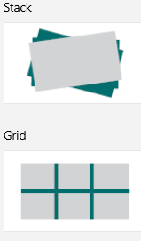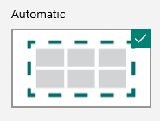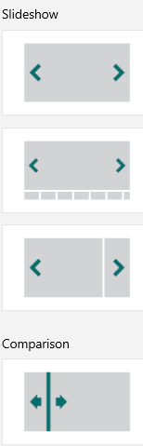Either select an already developed template or

start a new blank Sway.

Give the presentation a title.

Use Headlines to separate the presentation into sections.

* Groups will keep information within these sections together.
* Under the headlines, select TEXT to add short bullets of

Information to the presentaton.

* Click the PLUS SIGN to add pictures, videos, or songs for a

visual represenation of the given infromation.

*Create new headlines and groups for each new sections.*

TO START A NEW GROUP CLICK UNDER THE CURRENT GROUP FOR

ADDITIONAL SELECTIONS.

When adding pictures, use CREATIVE COMMONS ONLY.

Select STYLES on the right side of the edit view to change the

presentation’s color scheme.



Choose how the information will be presented.