Name: Date:

**Read the story.**

**It’s Valentine’s Day!**





Maura decides to paint a valentine. First, she writes her name on her paper. Then, she chooses her paints.

Maura chooses red and pink paints. Next, Maura chooses a paint brush. Finally, she paints two valentine hearts.

**Write the numbers 1-4 in the boxes to show the correct order.**

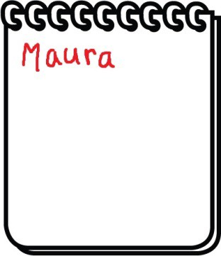

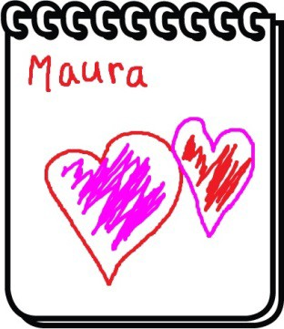

CCSS. RL.1.2 |© [http://www.englishworksheetsland.com](http://www.englishworksheetsland.com/)