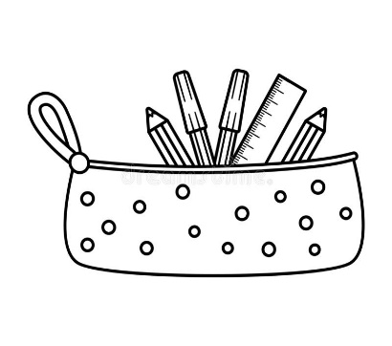

**Mrs. Adamson-Carroll’s Supply List**

pencil case soft or hard to be kept at desk (label with child’s full name)

4 composition notebooks (write full name on cover and label)

Label: Homework, ELA, Math and Writing

4 pocket folders (write full name on cover and label) Label:Homework, Writing, ELA, Science and Social Studies

2 packages of pencils sharpened

1 pair of headphones (labeled with name)

4 glue sticks

1 box of crayons

1 package index cards

1 package of expo markers

2 boxes of tissues

1 ream of white printer paper

1 container of Clorox or Lysol wipes

Please write your child’s name on their supplies. Please place crayons, expo markers and pencils in their pencil case box. Please label your child’s folders and notebooks with their name. This saves an enormous amount of time the first day so we can get ready to learn. I also allow students to keep water at their desk so you may want to purchase a reusable water bottle for the year. Thank you!