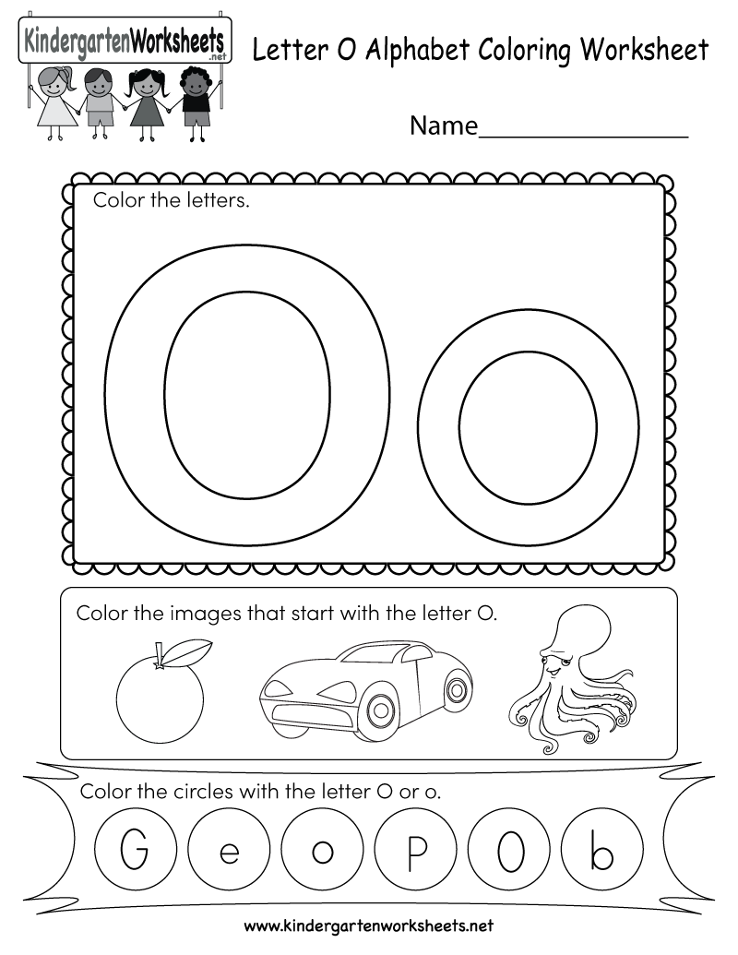

Directions: Write all the words that begin with the letter “O” on a piece of paper. Think of some more that are not here.

