# Name: Determining the Main Idea

Unlike most baby animals, human babies are born the most helpless. When a baby is born, it is unable to feed, walk, or dress itself. The baby’s bones are too soft for the baby to sit up or crawl just yet. Without teeth, the baby will spend most of its first few months drinking milk and eating soft foods. As the bones begin to get stronger, the baby will begin to hold its head up and reach for objects a in front her.

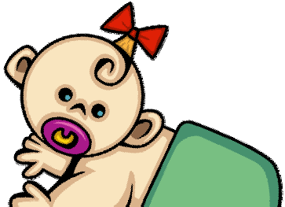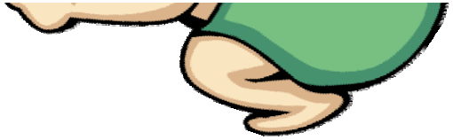

Most babies will start rolling over before trying to crawl. By the time they are learning to crawl, their teeth are also beginning to grow in. When baby’s teeth start to grow in, their gums can be very tender causing them to cry and often have fevers. Once their teeth come in, they can then start eating foods that are soft and a little chunkier. Some babies also begin talking as they are learning to crawl and walk. Their first words are sometimes “mama” and “dada”.

List 3 supporting details from the paragraphs above.

List 3 supporting details from the paragraphs above.

What is the main idea of these paragraphs? (the topic)

# CCSS.RI.2.2 | © [www.EnglishWorksheetsLand.com](http://www.EnglishWorksheetsLand.com/)