**Understanding Natural Selection Lab Activity**

Objective: understand how natural selection can affect whole populations.

Materials: beak types: tweezers, clothespin, chopsticks, spoons, forks

Food types: various sized candies

Storage/timer: cups, stop watch

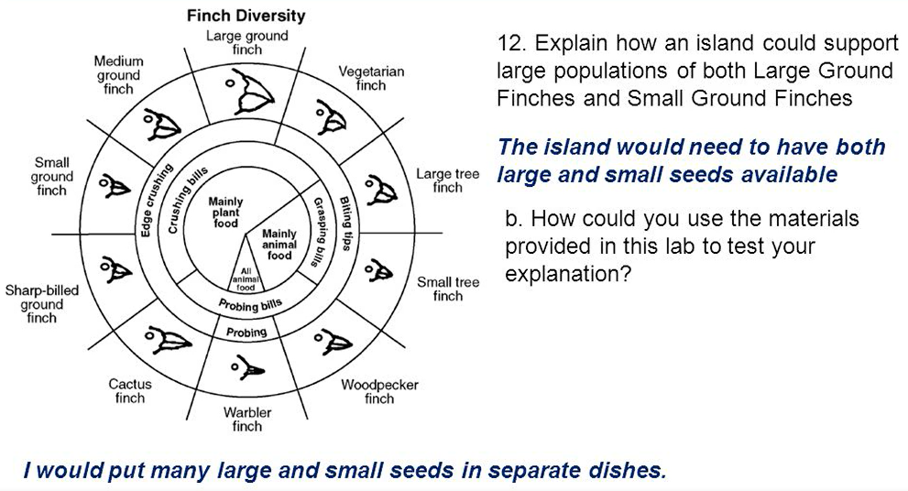

Procedure:

1. Each group member chooses a different tool (beak) to use.
2. On the teacher’s count, use your “beak” to pick your food (candy), placing each captured food item in your cup. Continue until time is called.
3. Count the number of food items you were able to pick up.
4. With your group members, tally how many each of your was able to pick up with their respective beaks.
5. Chart your findings.

**Understanding Natural Selection Post Lab Activity Questions**

Read each question carefully. Answer each question in complete sentences.

1. How might an island like the Galapagos support large populations of both Large Ground Finches and Small Ground Finches?
2. How could you use the materials provided in this lab to test your explanation?
3. The differences observed in the bird beaks in the given diagram are most likely due to
4. The genetic recombination associated with miotic cell division
5. The genetic engineering of the DNA of each of these species
6. Asexual reproduction of these finches species
7. The selection for different shaped beaks that best suit different niches
8. Which finch species is least likely to survive drought that reduces the plant population on the island?
9. Large ground finch
10. Medium ground finch
11. Small ground finch
12. Cactus finch

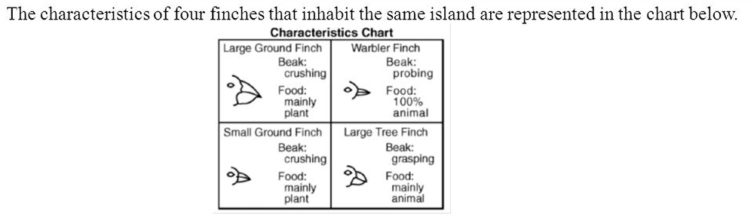

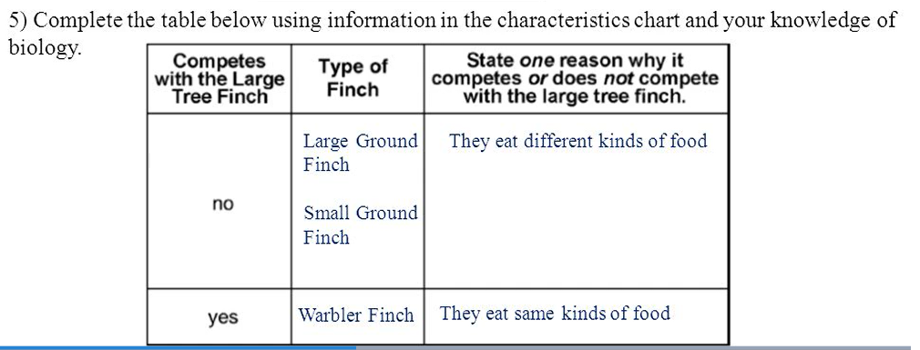

Questions 6-8 are based on the following passage.

When Charles Darwin traveled to the Galapagos Islands, he observed 14 distinct varieties of finches on the islands. Darwin also observed that each finch variety ate a different type of food and lived in a slightly different habitat from other finches. Darwin concluded that the finches all shared a common sense ancestor, but had developed different beak structures.

1. The 14 varieties of finches mentioned in the reading passages are most likely the result of
2. Lack of competition
3. Asexual reproduction
4. Biological evolution
5. Absence of biodiversity

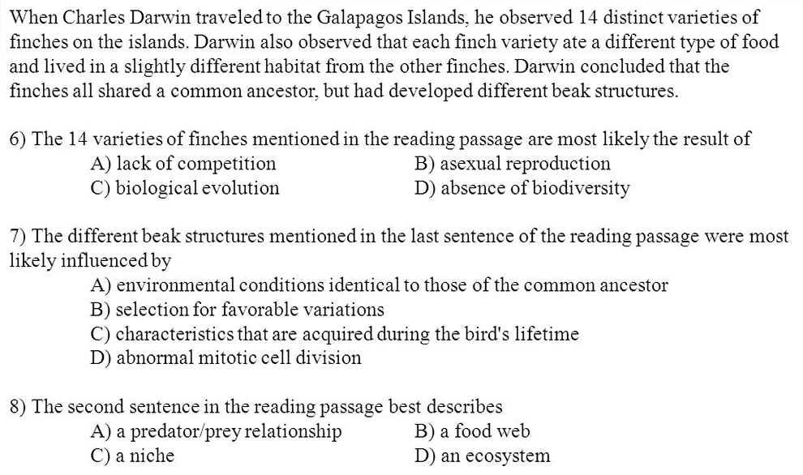

Questions 9 & 10 are based on the following diagram.

