Name:

**What is the Main Idea?**

Using Details to Determine the Main Idea

Computers have made life easier for most people who use them. They can hold information and allow us to create all kinds of neat projects that can be saved for us to view whenever we need it. **Computers have come a long way since they were invented.** A long time ago, most computers were so big; they were the size of an entire room! Now they are small enough for everyone to have in their homes. We even have some in our schools for everyone to use.

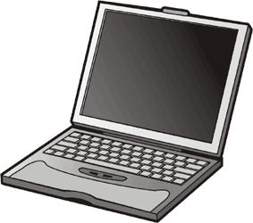

Computers that should not be move around a lot and need to stay in place are called desktop computers. Desktop computers are usually several pieces of the computer hooked up together such as the screen monitor, the hard drive unit, and speakers. Many newer desktop computers have all the pieces loaded inside the monitor. Desktops are not meant or designed to be moved around very often and they need to be plugged in at all times to be used.

Another neat invention with computers has been the ability to take them with you wherever you go. Laptops are computers that you can plug into a power outlet to charge its battery. Once the battery is fully charged, laptops can be carried anywhere you are going. It can sit on your lap and be used as long as the battery is charged. Unlike the desktop, laptops are usually lighter since they do not need to say in one place. The hardware inside the laptop that makes it work is much sturdier so it can handle lots of moving around.

Laptops and desktop computers perform all the same functions for users. They both come with the ability to connect to the internet and other devices using wireless options without needing cords. However, the desktop must be handled more carefully and move around less to protect the inside of its hardware.

# Use the paragraphs above to determine the important details and main idea.

**List 2 important details List 2 important details List 2 important details**

CCSS.RI.2.2 | © [www.EnglishWorksheetsLand.com](http://www.EnglishWorksheetsLand.com/)