Juan Bobo Goes Up and Down the Hill
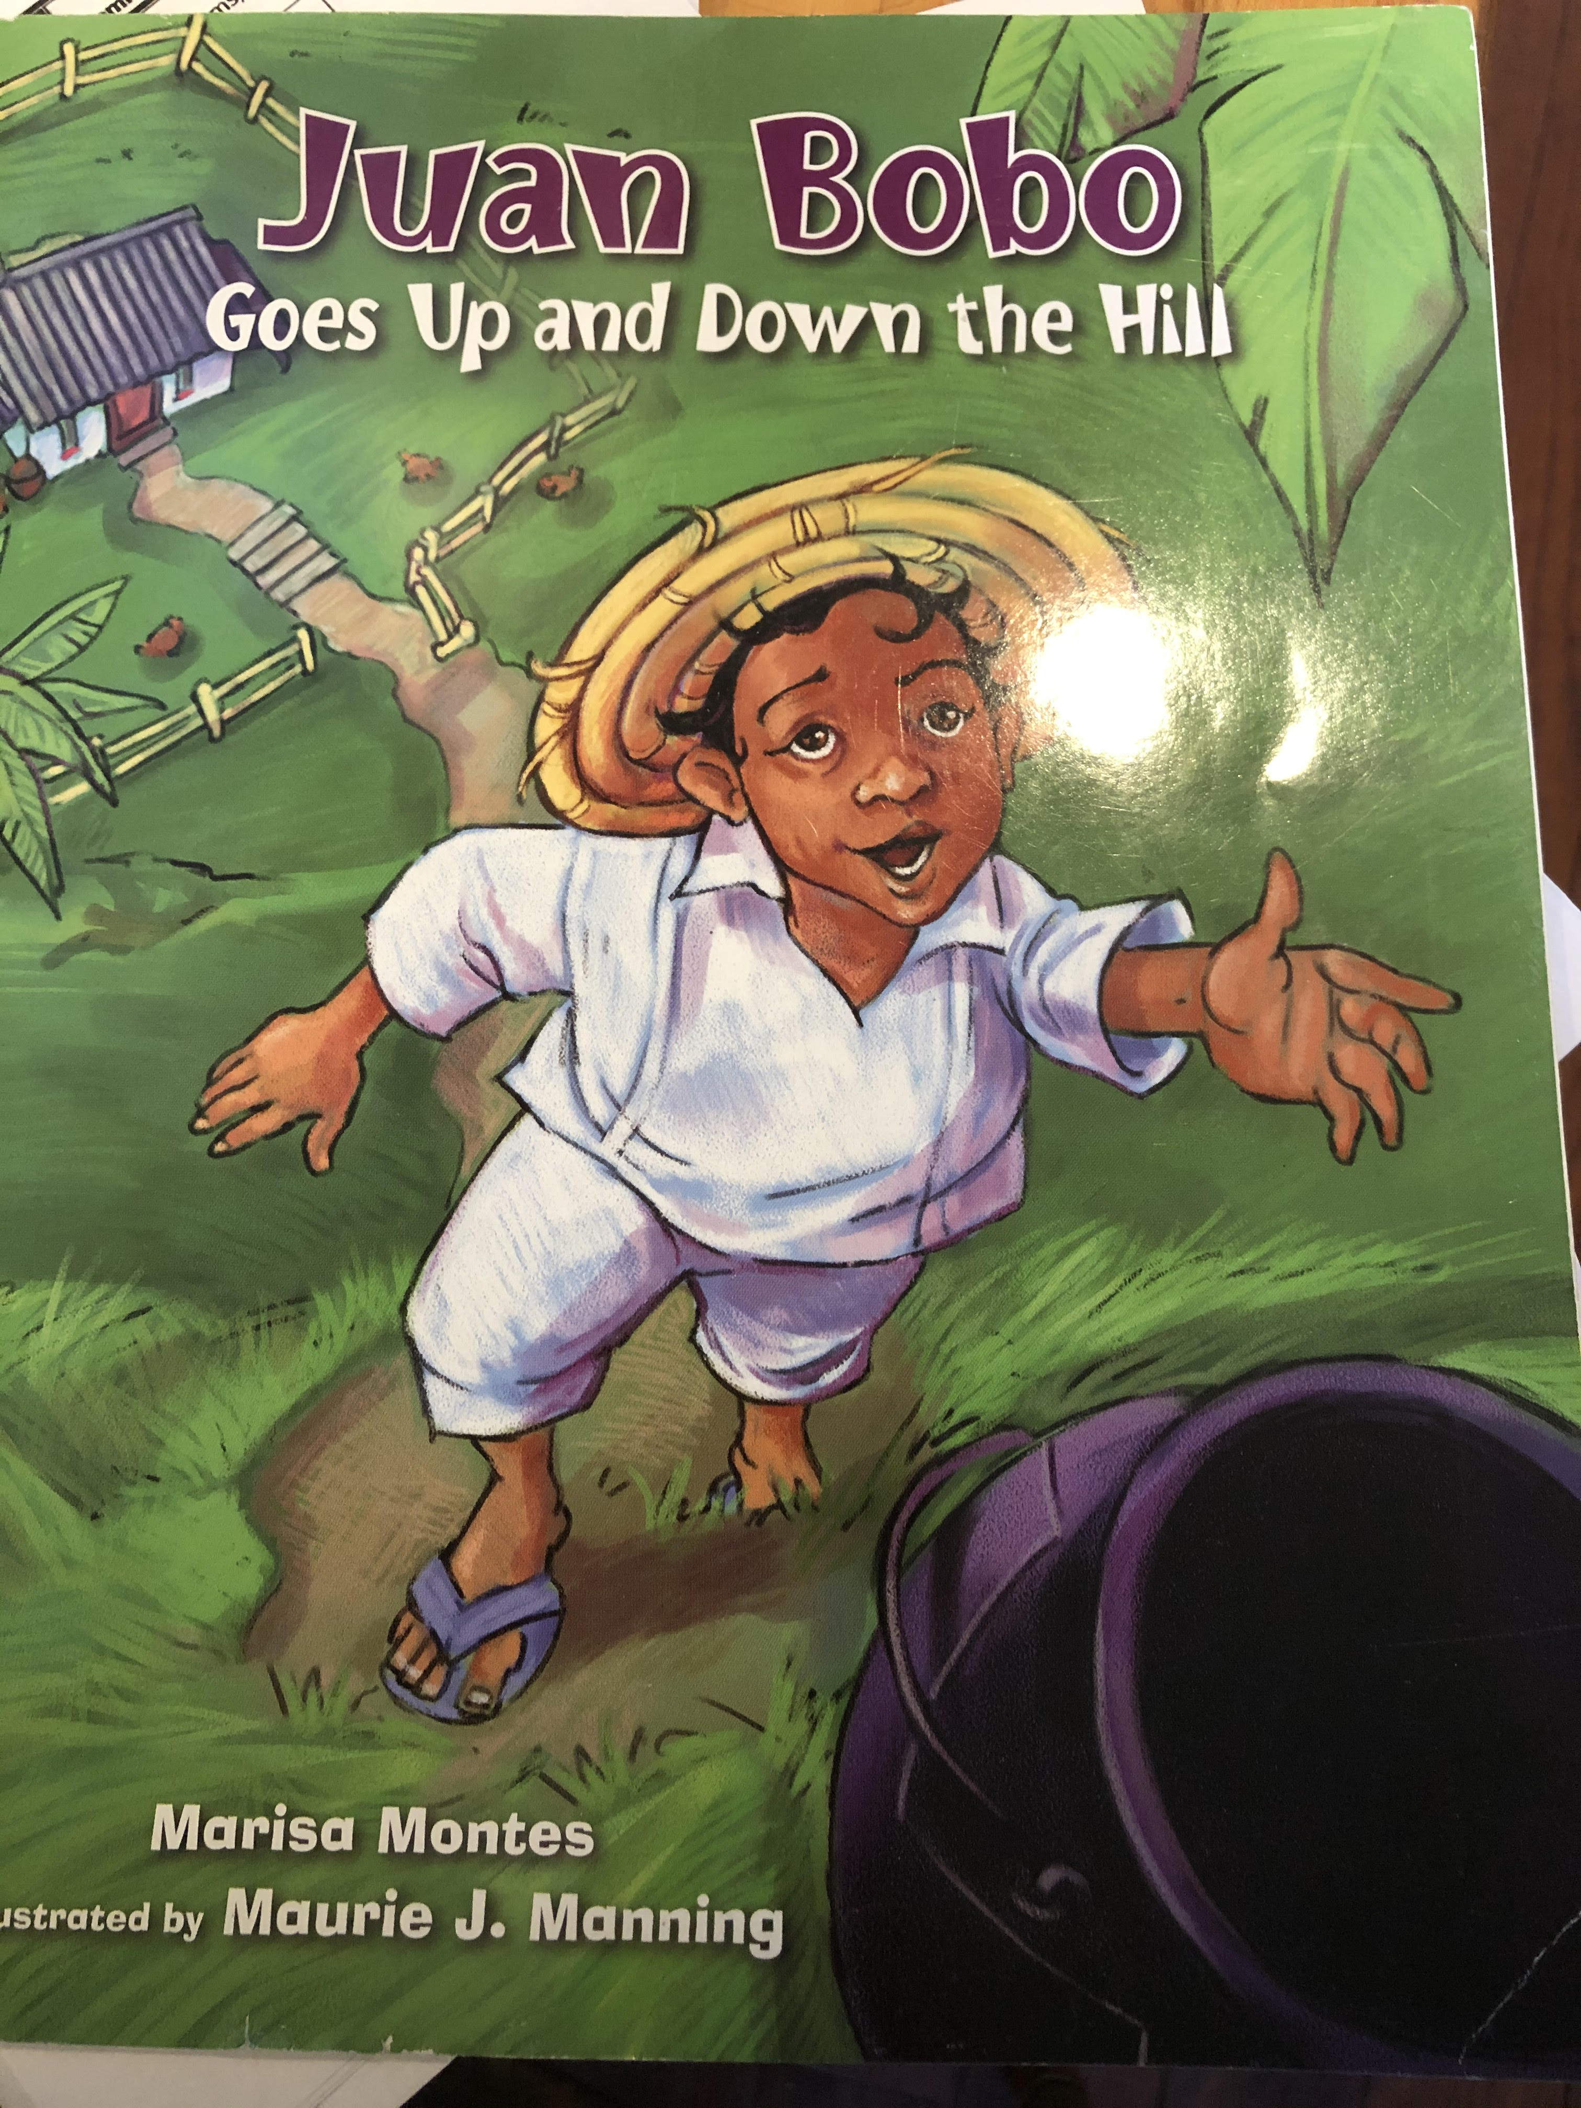
1. (page 2)
The characters in the story are _______________________, _______________________ and _____________________.
2. Draw a picture of where Juan Bobo lived. Label the drawing.
3. (page 7)
Juan Bobo’s mother wanted to make ____________________.
4. (page 9)
The color of the pot was _______________________ and it had _____________________legs.
5. (page 32) Write a complete sentence to answer the question.
What did Juan Bobo do while his Mama made soup?

