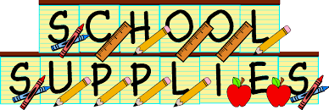

**Kindergarten Supply List**

**We request the following items:**

**Items are also available online at** [**www.1stDaySchoolSupplies.com**](http://www.1stDaySchoolSupplies.com)

**• 2 Primary Lined Journals with a space at the top**

* **1 Primary Composition Notebook with no space at the top**

**• 5 Jumbo glue sticks**

**• 8 pack of Crayola multicultural crayons**

**• 8 pack box of Crayola chubby crayons**

**• 8 pack box of Crayola markers**

**• 24 pack box of Crayola crayons**

**• 1 letter-sized FLAT clipboard-(no large clip at the top)**

**• 1 pack of EXPO dry erase markers (multi-color)**

**• 2 packs of EXPO SKINNY dry erase markers (black only-not fine point)**

**• 1 pair of Fiskars scissors. (blunt tip only)**

**• Crayola watercolor paint set (Botvinnik only)**

**• 1 pink eraser**

**• 1 box of Ticonderoga pencils—sharpened**

**• 1 box of Ticonderoga Beginner pencils-sharpened**

**• 3 plastic folders with pockets-no prongs (Botvinnik only)**

**• 1 plastic pencil box (8 5/8”L x 5 3/9” W x 2 ½ “ H) please adhere to this size**

**\*Additional item needs to be purchased and is not available online with the**

* **Package -1 child size headphones (no ear buds)\***

**Please note that an additional list of cleaning supplies will be sent home with your child during the first week of school.**