Juan Bobo Goes Up and Down the Hill
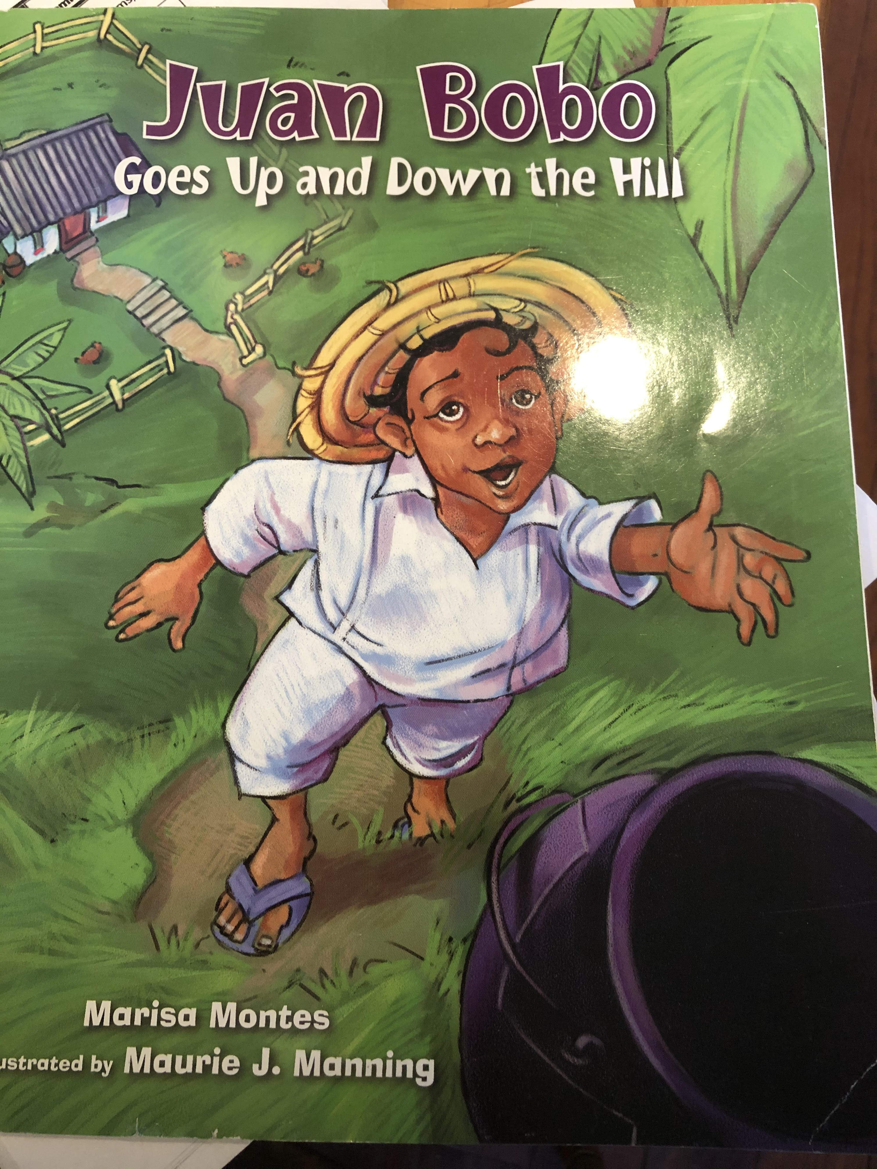
Directions: Answer the questions in complete sentences.
- Who are the characters in the story? (page 2)

- What kind of place does the story take place in?
(Look at the pictures and the cover.)

- What did Juan Bobo’s mother want him to do? (page 7)

- What did the pot look like? (page 9)

- What did Juan want to do? (page 11)

6. Where in the cupboard was the pot? (page 15)

7. How did Juan Bobo try to carry the pot down the hill? (page 18)

8. How did Juan Bobo get the pot down the hill? (page 29)

9. Who won the race down the hill? (page 31)

10. What did Juan Bobo do while his Mama made soup? (page 32)

