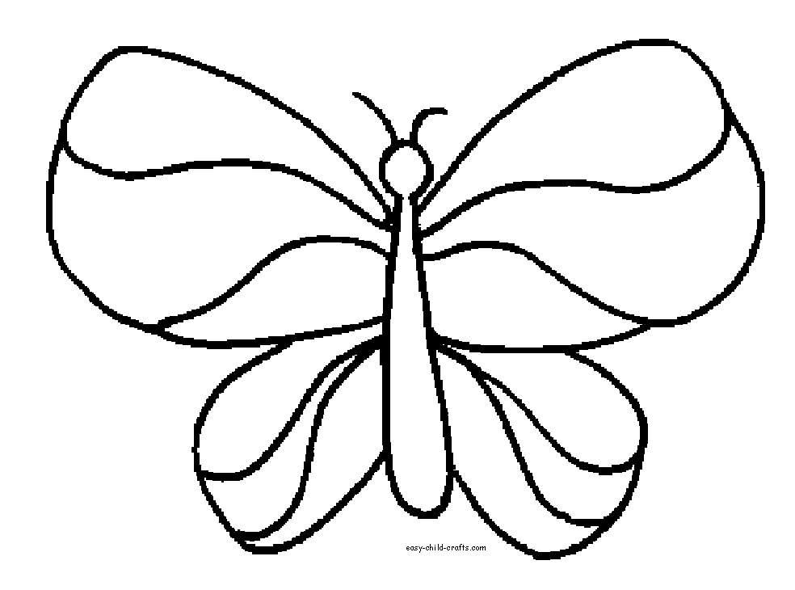

go

go

**up**

the

the

go

see

see

the

the

see

see

go

Color **go** red. Color **see** blue. Color **the** green. Color **up** purple