**Name**

**Fill‐in‐the‐Blank**

**Date**

**Directions:** Looking at the pictures and using the clues, fill in the blank with the letter that the picture starts with. Next to each picture, write another word that starts with the same letter.

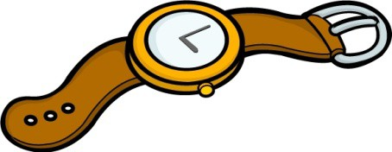W is for atch.

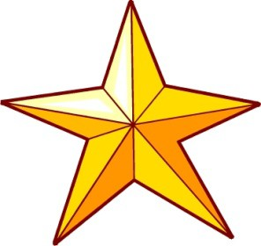C is for ake.

S is for tar.

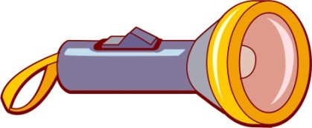F is for lashlight.

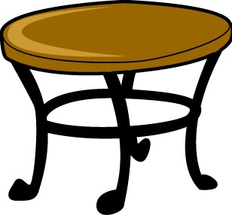T is for able.

CCSS.RF.K.1.D |© [http://www.englishworksheetsland.com](http://www.englishworksheetsland.com/)