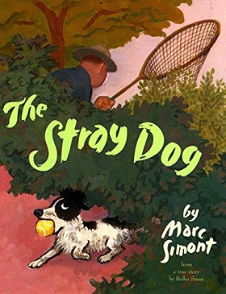

Haz un dibujo de las cosas que debes hacer para cuidar a un perro.

Draw a picture of the things you need to do to take care of a dog.

|  |
| --- |
|  |

Escribe sobre lo que haces para cuidar a un perro.

Write about what you do to take care of a dog.

__________________________________________________________________________________________________________________________________________________________________________________________________________________