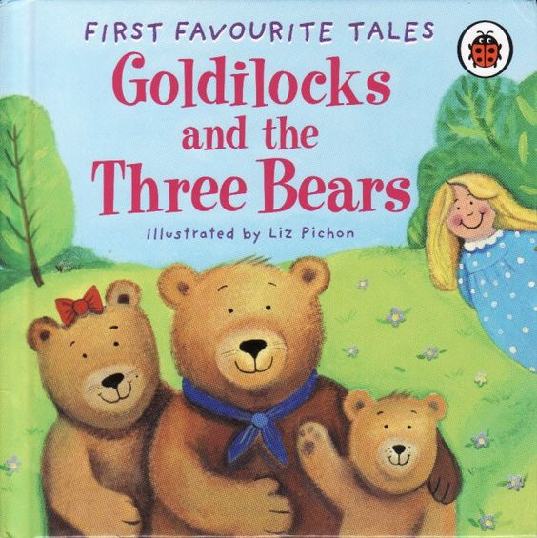

Dibuja la historia de "Los tres osos". Etiqueta tu dibujo.

__________________________________________________________________________________________

Draw the story of “The Three Bears”. Label your drawing.

|  |  |  |
| --- | --- | --- |
|  |  |  |