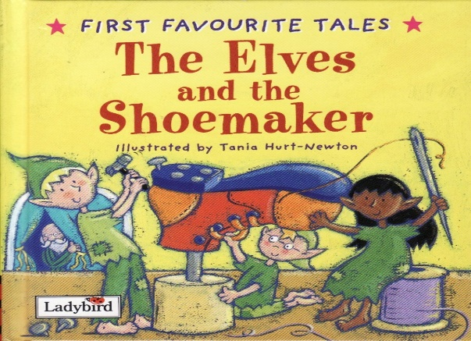

Haz un dibujo de la historia. Etiqueta tu foto.

Draw a picture from the story. Label your picture.

|  |
| --- |
|  |

Escribe una oración sobre tu dibujo.

Write a sentence about your picture.

______________________________________________________________________________________________________________________________