Name Recognizing Spoken Words in Writing

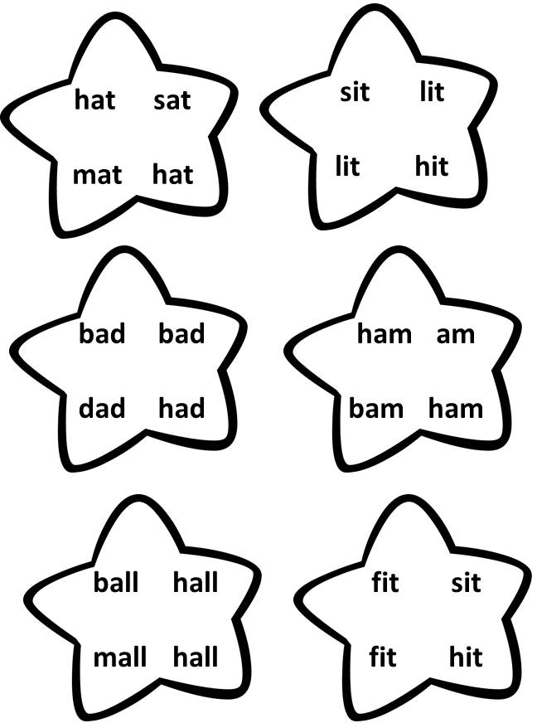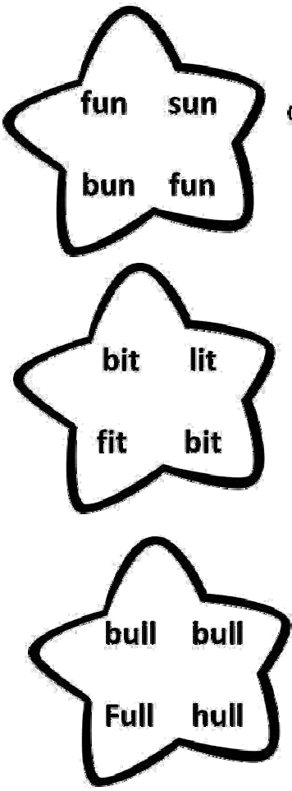

**Find the Same Word**

Read each set of words. Find the two in each set that match. Underline them.

**1. 2. 3.**

**4. 5. 6.**

**7. 8. 9.**

CCSS.RF.K.1.B | © [www.EnglishWorksheetsLand.com](http://www.EnglishWorksheetsLand.com/)