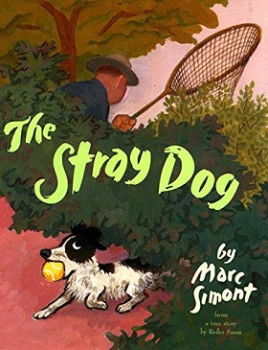

Haz un dibujo de lo que harías si encontraras un perro callejero.

Draw a picture of what you would do if you found a stray dog.

|  |
| --- |
|  |

Escribe una oración sobre tu dibujo.

Write a sentence about your picture.

______________________________________________________________________________________________________________________________