Exhibit A: Pericles Brings Stability, Wealth and Democracy to Athens
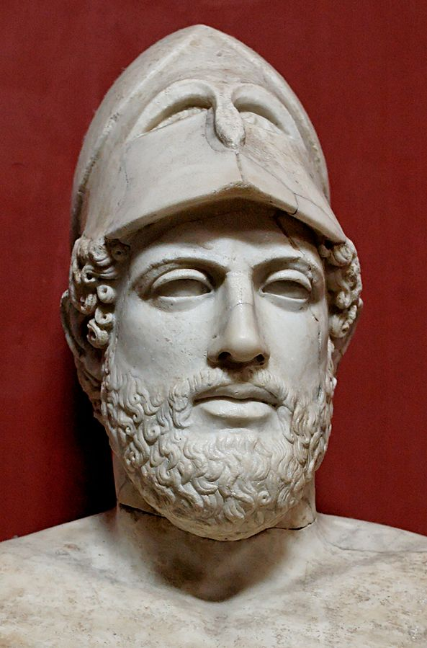
Throughout the 400s BCE the Greeks fought against their rivals to the east, the Persian Empire, in the Greco-Persian Wars. During one of these wars that started in 486 BCE, the Persians invaded Greece and sacked Athens, but the Greeks defeated the Persians because of Athens’ dominant navy. With an advantage over the Persians, the Greeks, led by the city-state Athens, formed an alliance called the Delian League, whose purpose was to continue fighting the Persian Empire. The city-states gave money to the Delian League to support the troops who defended them.
Copy of a Bust of Pericles created in ca 430 BCE.
Source: https://en.wikipedia.org/wiki/File:Pericles_Pio-Clementino_Inv269_n2.jpg

Pericles (495–429 BCE, whose name means "surrounded by glory") was a prominent statesman, famous orator [speaker], and general of Athens during the Golden Age of Athens. So profound was his influence that the period in which he led Athens has been called the 'Age of Pericles’.
Pericles started to use the Delian League to control the other Greek city-states and he moved the League’s treasury (where its money was kept) to Athens for his city-state to use for their benefit. By using the troops and money, Pericles turned Athens into a wealthy empire.

Pericles promoted the arts, literature, and philosophy and gave free reign to some of the most inspired writers and thinkers of his time. During the Age of Pericles, Athens blossomed as a center of education, art, culture, and democracy. Artists and sculptors, playwrights and poets, architects and philosophers all found Athens an exciting and enlivening atmosphere for their work.

Source: Adapted from “Pericles,” Ancient History Encyclopedia. http://www.ancient.eu/pericles/

Exhibit B: Architecture
Greek architects provided some of the finest and most distinctive buildings in the entire Ancient World and some of their structures, such as temples, theatres, and stadiums, became staple features of towns and cities from antiquity [Classical Era] onwards. In addition, the Greek concern with simplicity, proportion, perspective, and harmony in their buildings would go on to greatly influence architects in the Roman world and provide the foundation for the classical architectural orders [styles] which would dominate the western world from the Renaissance to the present day.
Greek Columns  Greek architects created the three “orders,” or styles, of columns. Those three, depicted in the image below are the Doric, Ionic, and Corinthian orders. These styles are still common on many modern buildings especially museums, libraries, and government buildings.  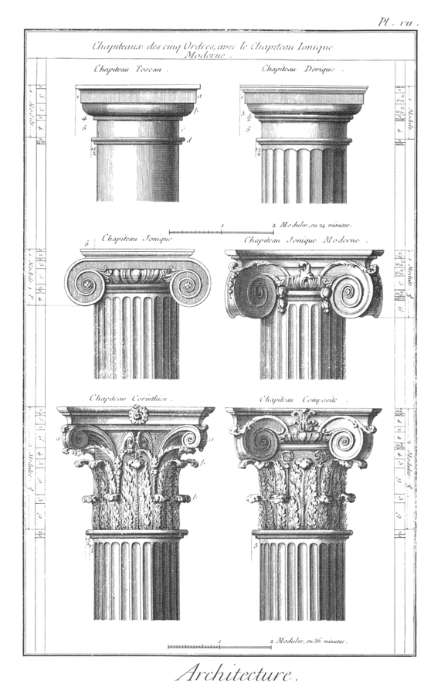  Doric, Ionic, and Corinthian styles of Greek Columns an engraving from the Encyclopédie vol. 18. 18th-century French engraving.  Source: https://en.wikipedia.org/wiki/File:Classical_orders_from_the_Encyclopedie.png | The Parthenon

Watch an excerpt of Secrets of the Acropolis: Blowing Up History, read the text, and examine the image below.
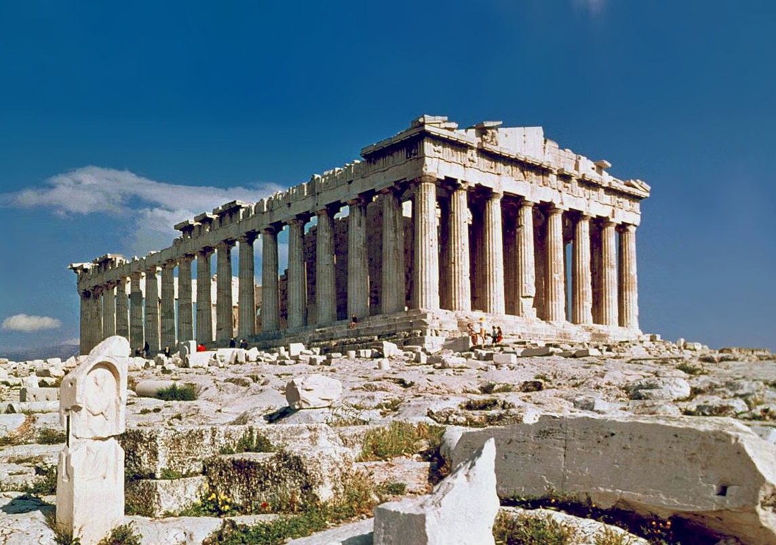
The Parthenon on the Acropolis in Athens, Greece
Source: https://commons.wikimedia.org/wiki/File:The_Parthenon_in_Athens.jpg
The magnificent temple on the Acropolis of Athens, known as the Parthenon, was built between 447 and 432 BCE in the Age of Pericles, and it was dedicated to the city’s patron deity, Athena. The Acropolis was the center of Athenian life built on top of a hill in the city where the most important civic buildings were located. The acropolis itself measures some 300 by 150 metres and is 70 metres high at its maximum. Marble from the nearby Mt. Pentelicus was used for the building, and never before had so much marble been used in a Greek temple.

Source: Adapted from “Parthenon.” Ancient History Encyclopedia. http://www.ancient.eu/parthenon/

Exhibit C: Visual Art: Sculpture
Before the Age of Pericles, Greek sculpture represented the human form as stiff and rigid. During the Golden Age of Athens, artists developed a more realistic and idealized style in their sculpture. The people or gods represented in these sculptures stand in more natural poses and represent what Greeks thought of as the ideal human body.
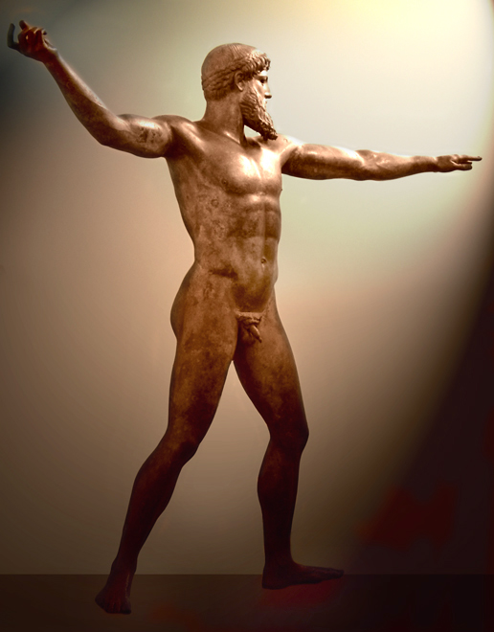
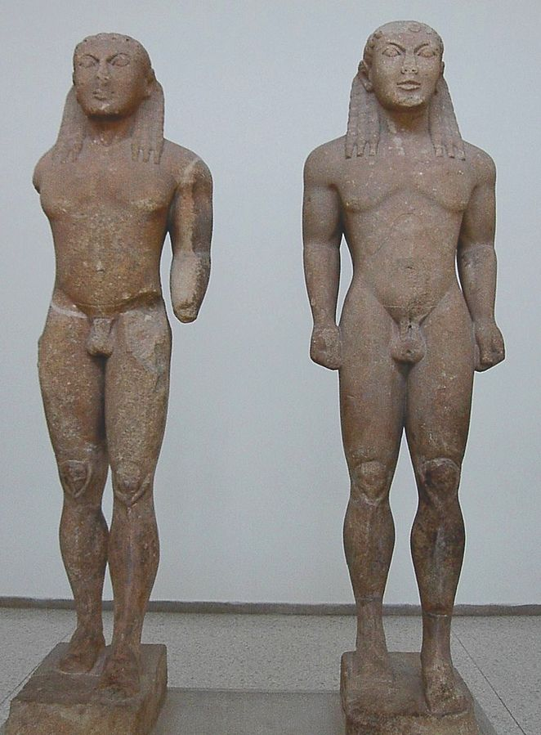
The Artemision Bronze, Statue of Poseidon (or Zeus) created about 470-440 BCE is an example of realistic and idealized sculpture from the Golden Age of Greece.
Source: https://en.wikipedia.org/wiki/File:Netuno19b.jpg
Example of Greek sculpture before the Golden Age of Athens
Source: https://en.wikipedia.org/wiki/File:Ac.kleobisandbiton.jpg
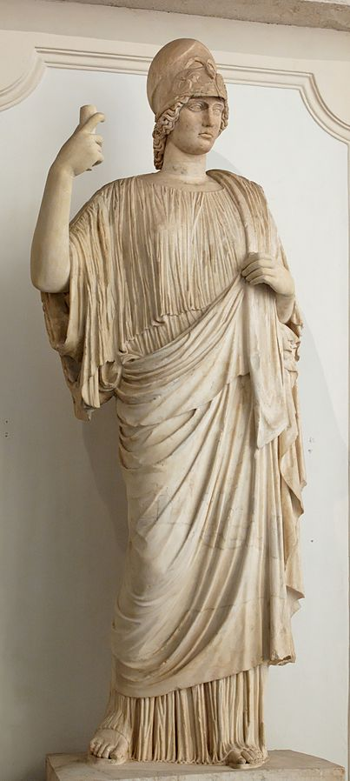
Statue of Athena, Roman copy of a Greek original from the 5th century BCE.
Source: https://en.wikipedia.org/wiki/File:Athena_Giustiniani_Musei_Capitolini_MC278.jpg

Exhibit D: Literature
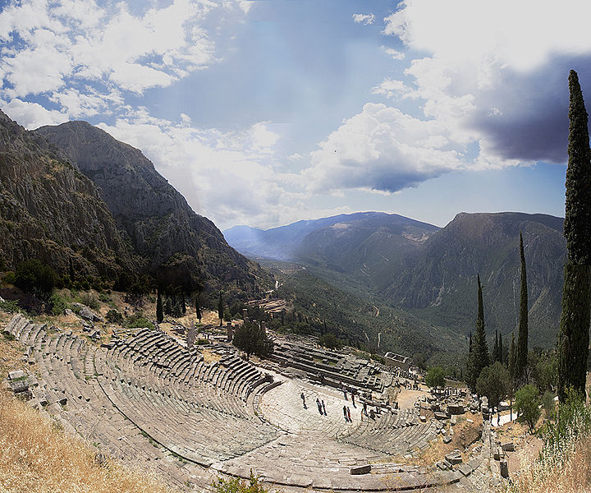
Epic Poetry
A composite of several images taken of the Theatre of Delphi.
Source: https://commons.wikimedia.org/wiki/File:Delphi_Composite.jpg
Though he was not alive during the Golden Age of Athens, the poet Homer was an important figure in Greek literature. He wrote two epic poems that are still read today: the Iliad and the Odyssey. These two stories about adventure, war, and tragedy are still used as templates for modern storytellers.
Theater
Greek playwrights wrote drama and comedies which were performed regularly in theaters and at festivals. Of the hundreds of plays written and performed during the classical age, only a limited number of plays by three authors have survived: Aeschylus, Sophocles, and Euripides. Sophocles' life covered nearly the whole period of Athens' "golden age." He won more than 20 victories at the Dionysian festivals and produced more than 100 plays, only seven of which remain. His drama Antigone is typical of his work: its heroine is a model of womanly self-sacrifice. He is probably better known, though, for Oedipus the King and its sequel, Oedipus at Colonus.
Source: Adapted from “Ancient Greek Literature.” New World Encyclopedia. http://www.newworldencyclopedia.org/entry/Ancient_Greek_literature

Exhibit E: Philosophy
Philosophy is the study of ideas about knowledge, truth, and the nature and meaning of life. In Classical Greece, philosophy flourished. Athenians valued education, and as a result, philosophers were able to start their own schools and debate one another. The ideas that came from Classical Greece were written down and passed around to other civilizations in the Eastern hemisphere. These ideas greatly impacted global history. The three most well known philosophers were Socrates, Plato, and Aristotle.
Socrates  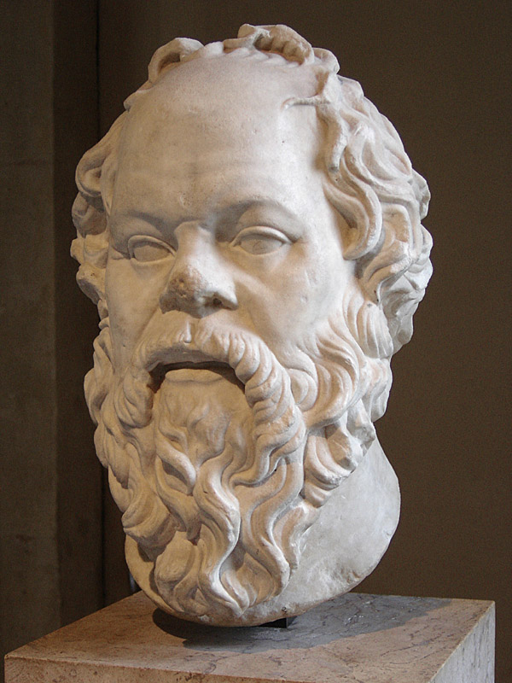  Source: https://en.wikipedia.org/wiki/File:Socrates_Louvre.jpg | Plato  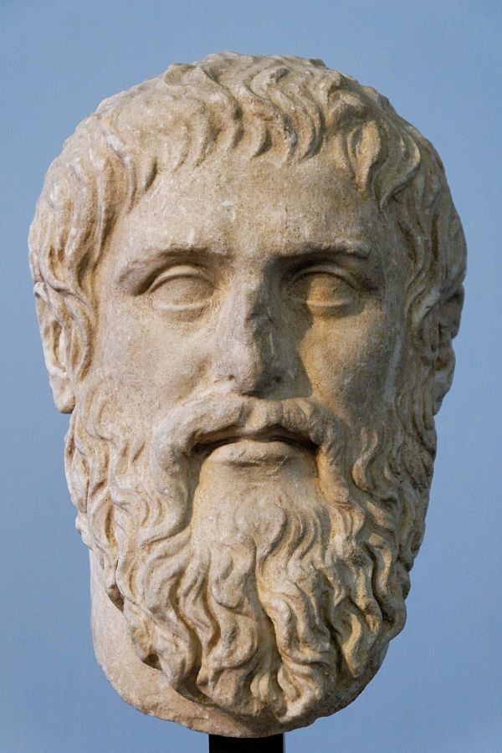  Source: https://en.wikipedia.org/wiki/File:Plato_Silanion_Musei_Capitolini_MC1377.jpg | Aristotle  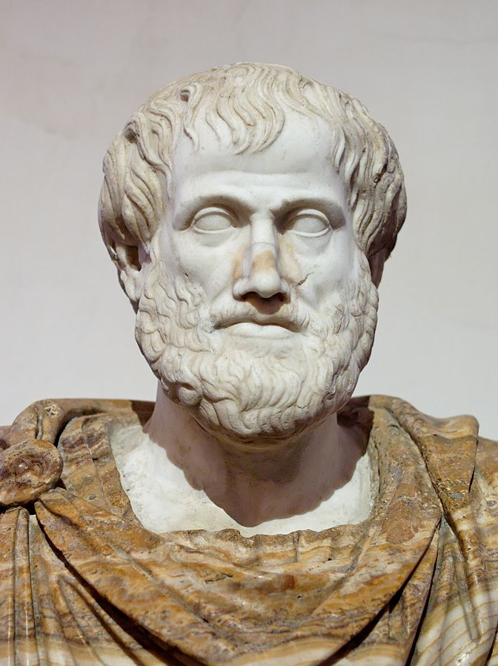  Source: https://en.wikipedia.org/wiki/File:Aristotle_Altemps_Inv8575.jpg
- Focused on moral and psychological questions  - Used a series of questions in debates to show the flaws in others’ ideas- a style now called the “Socratic Method” | - Student of Socrates  - Discussed ethics, politics, and the nature of ideas | - Student of Plato and tutor for Alexander the Great  - Advances in science and logic influenced scholars for thousands of years
Source: “Greek Philosophy.” Ancient History Encyclopedia. http://www.ancient.eu/Greek_Philosophy
Exhibit F: Herodotus, The Father of History
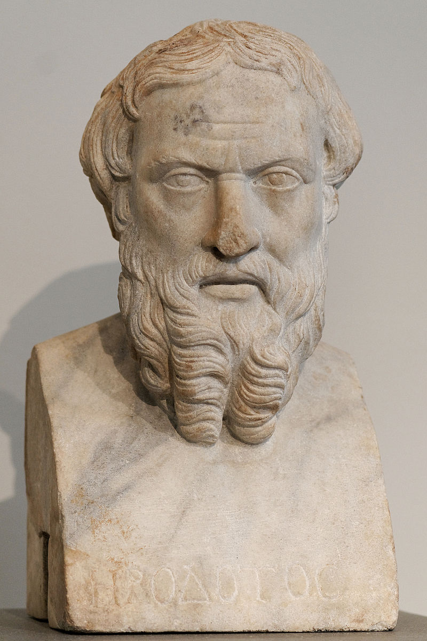
Herodotus (c. 484 – 425/413 BCE) was a writer who invented the field of study known today as `history’. He was called `The Father of History’ by the Roman writer and orator Cicero for his famous work The Histories but has also been called “The Father of Lies” by critics who claim these `histories’ are little more than tall tales. Criticism of Herodotus’ work seems to have originated among Athenians who took exception to his account of the Battle of Marathon (490 BCE) and, specifically, which families were due the most honor for the victory over the Persians. More serious criticism of his work has to do with the credibility of the accounts of his travels.
Herodotos, Roman copy of a Greek bronze created in the 4th century BCE.
Source: https://commons.wikimedia.org/wiki/File:Herodotos_Met_91.8.jpg

Herodotus traveled widely in Egypt, Africa and Asia Minor and wrote down his experiences and observations, providing later generations with detailed accounts of important historical events (such as the Battles of Marathon and Peluseum); everyday life in Greece, Egypt, and Asia Minor; and on The Seven Wonders of the Ancient world.

Source: “Herodotus.” Ancient History Encyclopedia. http://www.ancient.eu/herodotus/

Exhibit G: Mathematics
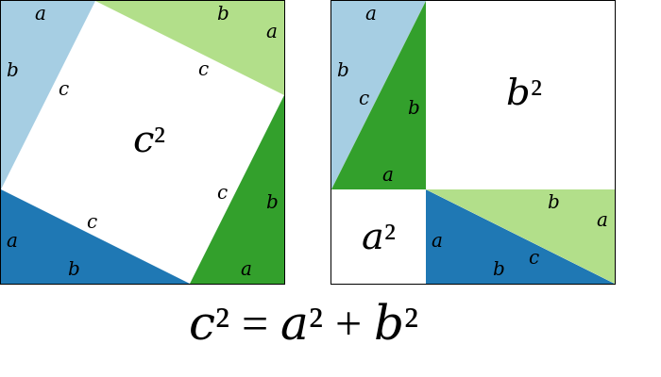
Greek artists and architects used mathematics to complete their projects and philosophers used it to explore the true nature of the world. For example, Pythagoras, a philosopher, developed a method for explaining the relationship between the angles and legs of right triangles now called the Pythagorean Theorem.
A proof for the Pythagorean Theorem
Source: https://en.wikipedia.org/wiki/Pythagorean_theorem

Exhibit H: Medicine
Hippocrates (ca. 460 B.C.E. – ca. 370 B.C.E.) was an ancient Greek physician of the "Age of Pericles," and was considered one of the most outstanding figures in the history of medicine. He is referred to as the "father of medicine" in recognition of his lasting contributions to the field as the founder of the Hippocratic school of medicine.
Very little is known about what Hippocrates actually thought, wrote and did. Nevertheless, Hippocrates is commonly portrayed as the perfect example of the ancient physician. In particular, he is credited with greatly advancing the systematic study of clinical medicine, summing up the medical knowledge of previous schools, and prescribing practices for physicians through the Hippocratic Oath and other works.
A modernized version of the Hippocratic Oath is still used today to induct new doctors into the field of medicine. In Classical Greece, the Oath required physicians to swear to Greek gods, the modern version does not.
Excerpt from the modern Hippocratic Oath
I swear to fulfill, to the best of my ability and judgment, this covenant:

I will respect the hard-won scientific gains of those physicians in whose steps I walk, and gladly share such knowledge as is mine with those who are to follow.

I will apply, for the benefit of the sick, all measures which are required...
I will remember that there is art to medicine as well as science, and that warmth, sympathy, and understanding may outweigh the surgeon's knife or the chemist's drug.
I will not be ashamed to say "I know not," nor will I fail to call in my colleagues when the skills of another are needed for a patient's recovery.
I will respect the privacy of my patients, for their problems are not disclosed to me that the world may know. Most especially must I tread with care in matters of life and death. If it is given me to save a life, all thanks. But it may also be within my power to take a life; this awesome responsibility must be faced with great humbleness and awareness of my own frailty. Above all, I must not play at God...
I will prevent disease whenever I can, for prevention is preferable to cure.
I will remember that I remain a member of society, with special obligations to all my fellow human beings, those sound of mind and body as well as the infirm.
If I do not violate this oath...May I always act so as to preserve the finest traditions of my calling and may I long experience the joy of healing those who seek my help.
Written in 1964 by Louis Lasagna, Academic Dean of the School of Medicine at Tufts University, and used in many medical schools today.
Source: “Hippocrates.” New World Encyclopedia. http://www.newworldencyclopedia.org/entry/Hippocrates; “More About the ‘Modern’ Oath’ http://guides.library.jhu.edu/c.php?g=202502&p=1335759

