10 exercises that boost child development and core strength

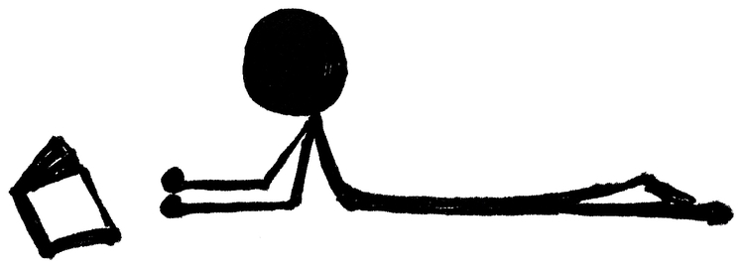

Tummy Time
Lay on your tummy, up on your elbows. No propping your chin on your hands
Keep your legs as straight as you can stretched out behind you
Activity Ideas
Read a book
Play dough games
Sticker games
Manipulatives/ blocks
Watching TV / video games
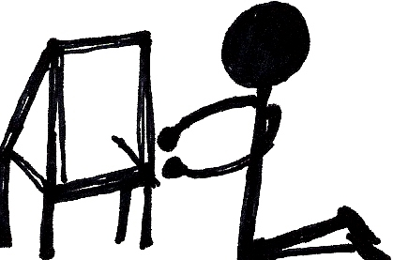

Tall Kneeling
Position yourself up tall on your knees.
Do not sit down on your heels stay up tall on your knees
Activity Ideas
- Tossing a ball back and forth
- Bouncing a ball to a person
- Bouncing a ball to the wall
- Games in front of the couch
- Games in front of a low table

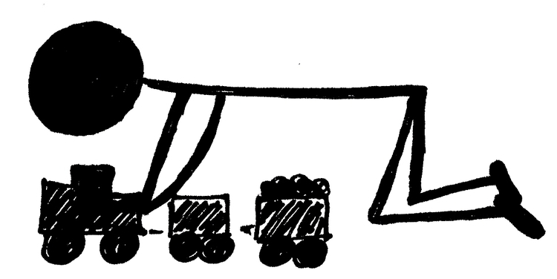

Hands and Knees
Position yourself in hands and knees.
Hold your tummy up and flat and keep your feet on the floor
Activity Ideas
- Reaching for pieces of a game
- Texture play on the floor
- Texture play up on the wall/ mirror
- Freeze Games/ Animal Pretend Play
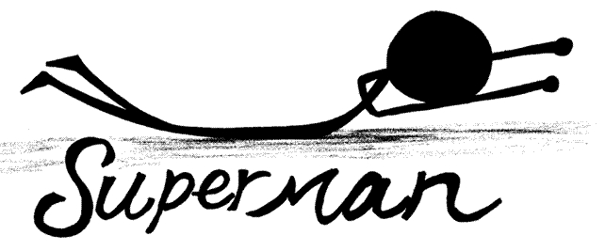

Superman / Prone Extension Activities
- Work on arm position first: hit a rolled or tossed ball with both hands or with alternating hands.
- Work to maintain head, chest, and arms in correct position between hits with the ball.
- Work into maintaining the full position with arms, head, legs
- Work in short bursts (1-15 seconds) and focus on increasing QUALITY of the position and then increase how long the child can hold it.

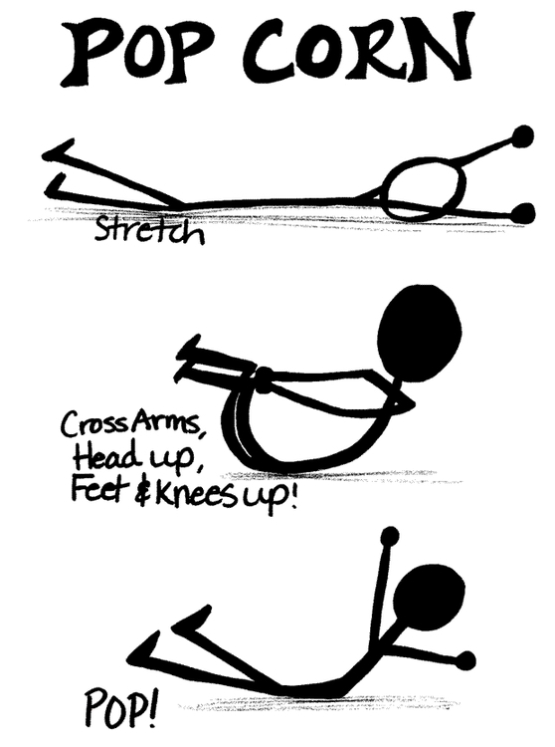

Popcorn/ Supine Flexion Activities
- Work on crossing arms over chest, bringing knees up to chest
- Encourage head tuck to complete the Popcorn position
- Work to maintain the position in short burst (1-15 seconds) and focus on increasing QUALITY of the position and then increase how long the child can hold it.
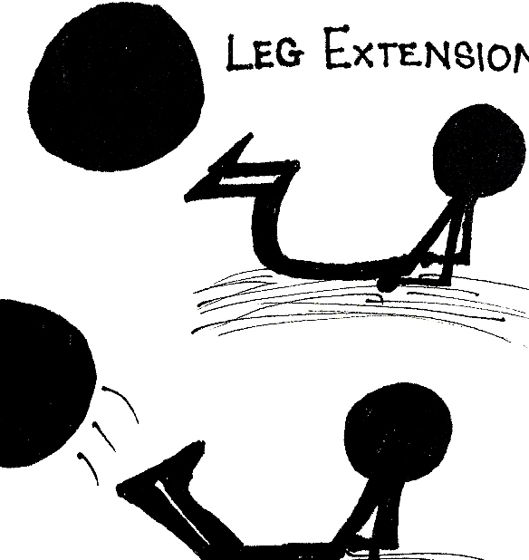

Leg Extension Activities
- Work on leg extension exercises next with tossed or suspended ball
- Hips should flex about 90 degrees and feet remain off the floor
- Encourage head up with long neck for leg extension activity
- Encourage legs working together and then alternating.
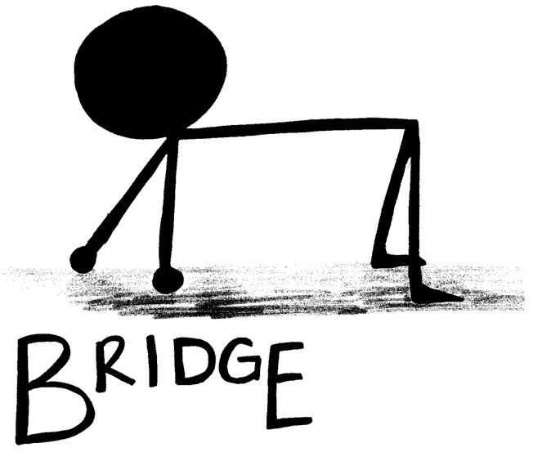

Bridge Activities
)
- Work on flat tummy (no sagging!) for short bursts (1- 15 seconds) and focus on increasing QUALITY of the position and then increase how long the child can hold it.
- When the child is able to hold the position with good alignment, begin lifting and straightening one leg at a time
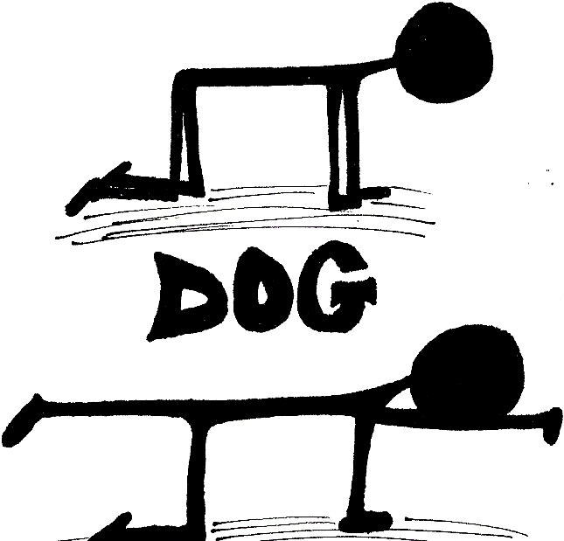

Dog Activities
- Begin with maintaining all fours and turning head side to side while keeping balance.
- Then add lifting alternating arms
- Then add lifting opposite arm/ leg together in an alternating pattern.
- This exercise can be connected to academic and visual scanning activities easily.
- Finally, add a head turn to lifting the opposite arm/leg together in an alternating pattern.
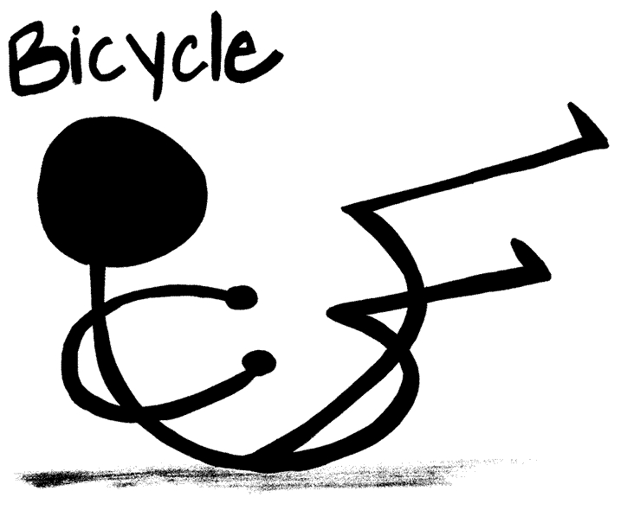Bicycle ActivitieS
- This exercise is built upon the skills learned in Popcorn/ Supine Flexion work. Pull into a partial popcorn position initially and then touch one hand or elbow to the opposite knee in an alternating pattern.
- This exercise is good to use during memory or spelling work to help increase memory work and recall of information.
- This exercise also supports processing speed.
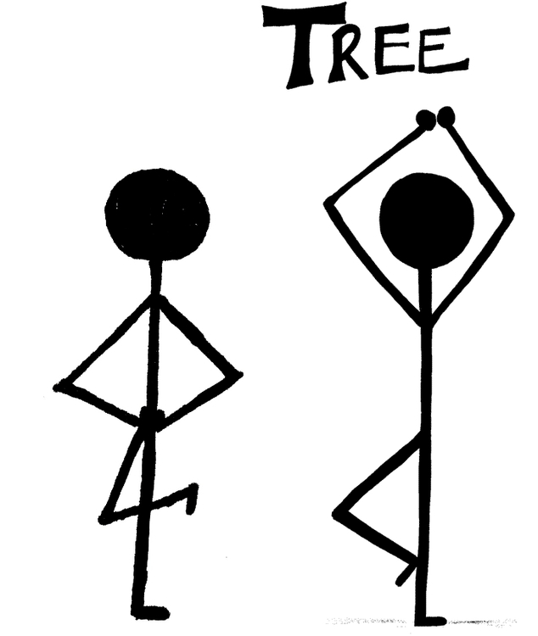Tree Activities
- Begin teaching standing on one foot by supporting the child at the hip joint and then fading your support to finger-tip touch. When the child can maintain balance on one foot with finger-tip touch for 10 seconds, you are ready to move to the next step.
- Encourage the child to place their hands on their hips or stretched out to the side while standing on one foot. Encourage them to maintain balance skills for increasing periods of time, building to at least one minute.Make it harder by repositioning the flexed leg into an abducted/ angle position with the foot resting on the opposite knee.
- Make it harder by repositioning the hands touching above the head.
- Build tree strength in the new positions to at least 60 seconds.
- Work on dynamic balance by standing on one foot and reaching with arms to complete a task or reach down to the ground to pick up objects.

