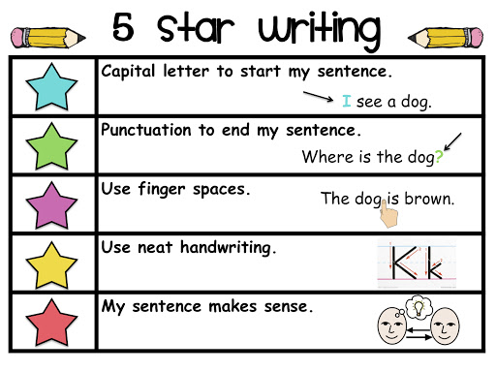

|  |
| --- |
| Which farm animal is your favorite  sheep, pig, cow or horse? |