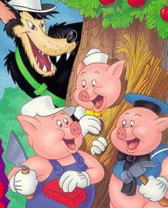 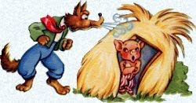

Dibuja la historia de "Los Tres Cerditos".  **Etiqueta** tu dibujo.

__________________________________________________________________________________________

Draw the story of “The Three Little Pigs”. **Label** your drawing.

|  |  |  |
| --- | --- | --- |
|  |  |  |