|  |  |  |
| --- | --- | --- |
|  |  |  |

**Unit 9: Oxidation Reduction**

**Electrochemistry**

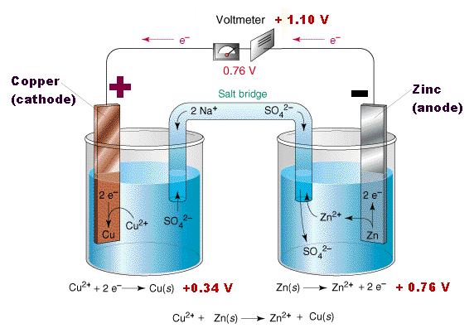

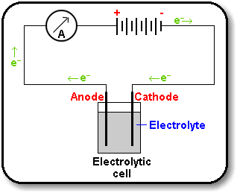

###### Vocabulary

Oxidation

Reduction

Redox

Oxidation Number

Oxidation Half Reaction

Reduction Half Reaction

Reducing Agent

Oxidizing Agent

Cathode

Anode

Electrode

Electrochemical Cell

Galvanic or Voltaic Cell

Salt bridge

Electrolytic Cell

###### Unit Objectives:

* Define and identify oxidation and reduction reactions
* Assign oxidation numbers to elements in a compound
* Write and balance half reactions
* Identify oxidizing agents and reducing agents
* Distinguish between voltaic and electrolytic cells
* Identify the components of an electrochemical cell
* Indicate the direction of electrons and ions through an electrochemical cell
* Determine, using Table J, whether a reaction if spontaneous or not

**REDuction – OXidation Reactions ( Redox Reactions)**

Rxns that involve the TRANSFER OF ELECTRONS; both reduction and oxidation

*must* happen SIMULTANEOUSLY!

**Reduction** = GAIN OF ELECTRONS by an atom or ion; OXIDATION NUMBER goes DOWN/REDUCES

**Oxidation** = LOSS OF ELECTRONS by an atom or ion; OXIDATION NUMBER goes UP/INCREASES

**A way to remember**

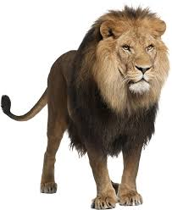

**L E O** the lion says **G E R**

Lose e- oxidation gain e- reduction

*Oxidation and reduction happen because of the DESIRE for electrons in a chemical reaction. Species prefer to either LOSE or GAIN electrons in a chemical reaction to gain stability.

**Oxidation and reduction are SIMULTANEOUS reactions and one cannot happen without the other. If one atom LOSES electrons, there must be another atom that will GAIN electrons.

Example: Al + CuCl2 🡪



+

Aluminum is above Cu on Table J so it will replace it!

**IDENTIFYING REDOX REACTIONS**

One way that we can begin to **identify a redox reaction** is to inspect the OXIDATION NUMBERS from reactant to product side (for every element involved in the reaction). Oxidation numbers are used to track the MOVEMENT OF ELECTRONS (electron transfer) from reactant to product side of rxn

**Oxidation Number (State) =** POSITIVE, NEGATIVE, OR NEUTRAL (ZERO) VALUES that can be assigned to atoms; used to identify how many electrons are being lost or gained by an atom/ion when they FORM BONDS

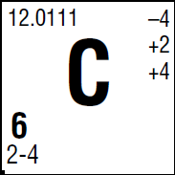

*top listed # to the upper right is the most common oxidation number for that element

Trick 1: SINGLE REPLACEMENT REACTIONS are always REDOX!

**0 +1 -1**

Example: Zn + HCl 🡪

+

Trick 2: DOUBLE REPLACEMENT REACTIONS are NOT REDOX!

**+1 -1 +1 -1**

Example: Na(OH) + HCl 🡪

+

*charges stay the same for all elements in the rxn

Trick 3: SYNTHESIS REACTIONS are always REDOX!

Example: Mg0 + S0 🡪

**Oxidation numbers**

**Rules for assigning oxidation numbers**

1. UNCOMBINED ELEMENTS (elements not bonded to another element) have an oxidation number of ZERO.

This includes any formula that has *only* one chemical symbol in it (single elements & diatomic elements).

Examples: Al(s)**0** Na(s)**0** Cl2(g)**0** H2(g)**0**

1. In COMPOUNDS, the sum of the CHARGES for all elements must ADD UP TO ZERO.

|  |  |  |
| --- | --- | --- |
| Ex: NaCl  Na: 1(+1) = +1 | Ex: | Mg3N2  Mg: |
| Cl: 1(-1) = -1  0! |  | N:  0! |

Ex: HNO3 H:

N:

O:

0!

* The OXIDATION NUMBER is the number INSIDE the PARENTHESES. It is the charge on ONE atom of that element!

** Remember that we almost always write the (+) ELEMENT FIRST and the (-) ELEMENT LAST in a compound formula.

EXAMPLE: HCl

EXCEPTION to this rule: NH3

1. GROUP 1 METALS always have a +1 oxidation number when in a compound (bonded to another species).

GROUP 2 METALS always have a +2 oxidation number when located within a compound.

**Ox #:**

Ex: LiCl MgCl2

1. FLUORINE is always a -1 in compounds. The other HALOGENS (ex: Cl, Br, I) are also -1 as long as they are the most electronegative element in the compound.

**Ox #:**

Ex: HF CaCl2 NaBr

1. HYDROGEN is a +1 in compounds unless it is combined with GROUP 1 or GROUP 2 METAL, in which case it is -1.

**Ox #:**

Ex: HCl LiH

1. OXYGEN is USUALLY -2 in compounds.

**Ox #:**

Ex: H2O

When combined with Fluorine (F), which is more electronegative, OXYGEN IS +2.

**Ox #:**

Ex: OF2

When in a PEROXIDE OXYGEN IS -1. A peroxide is a compound that has a formula of X2O2.

**Ox #:**

Ex: Na2O2 H2O2

1. The sum of the oxidation numbers in polyatomic ions must equal the CHARGE ON THE ION (SEE TABLE E).

Ex: Cr2O72- Cr: 2( ) = O: 7( ) =

= (charge on ion)

**A reaction is REDOX if…**

OXIDATION NUMBERS CHANGE FOR 2 ELEMENTS WITHIN A REACTION

**Reduction (GER)** = GAIN OF ELECTRONS by an atom or ion; OXIDATION NUMBER goes DOWN/REDUCES

**Oxidation (LEO)** = LOSS OF ELECTRONS by an atom or ion; OXIDATION NUMBER goes UP/ OXIDIZES

Assign oxidation numbers for all elements and complete the tables:

Example 1: CuCl2 + Zn 🡪 Cu + ZnCl2

|  |  |  |  |
| --- | --- | --- | --- |
|  | Charge: Increases/Decreases | e-: Lost/Gained | Oxidized/Reduced |
|  |  |  |  |
|  |  |  |  |

Example 2: MnO2 + 4HCl 🡪 MnCl2 + Cl2 + 2H2O

|  |  |  |  |
| --- | --- | --- | --- |
|  | Charge: Increases/Decreases | e-: Lost/Gained | Oxidized/Reduced |
|  |  |  |  |
|  |  |  |  |

**Oxidizing Agent (OA) =** SPECIES that is REDUCED; species that DOES THE OXIDIZING

**Reducing Agent (RA) =** SPECIES that is OXIDIZED; species that DOES THE REDUCING

*NOTE: OA & RA are ALWAYS located on the REACTANT SIDE! Assign oxidation numbers for all elements and identify the OA and RA:

CuCl2 + Zn 🡪 Cu + ZnCl2

Oxidizing Agent: ___________________

Reducing Agent ____________________

**Redox Worksheet #1 - Assigning Oxidation Numbers**

**Instructions:**

A. Assign oxidation numbers to all elements in both reactants and products.

B. Determine if two elements change in oxidation number.

If **YES**, the reaction is a **REDOX** reaction. Answer "C" and "D".

If **NO**, the reaction is not a redox reaction. Go to the next example.

C. Determine which element is oxidized and which element is reduced.

D. Determine which element is the oxidizing agent and which element is the reducing agent.

E. In the left margin, indicate the type of reaction (in addition to redox) each one is.

1.  ----->  + 

2. C +  -----> 

3, C +  -----> 

4.  +  -----> 

5. Ca +  -----> 

6. S +  -----> 

7. Ag + S -----> 

8.  ----->  + 

9.  +  -----> 

10. Mg + HCl ----->  + 

11.  +  -----> 

12.  -----> KCl + 

13. K +  -----> KOH + 

14. Al +  -----> 

15. Ca +  ----->  + 

16. Al + HCl ----->  + 

17.  +  ----->  + 

18.  +  ----->  + 

19.  + HCl ----->  + 

20.  +  ----->  + 

**Redox Reactions**

For the equations below, identify the substance oxidized, the substance reduced, The oxidizing agent, the reducing agent, and write the oxidation and reduction half reactions.

Example:

Oxidized Reduced

Mg + Br2 → MgBr2

Reducing Oxidizing

Agent Agent

Oxidation half reaction: Mg0 → Mg + 2e-

Reduction half reaction: 2e- + Br20 → 2Br-

1. 2H2 +O2  → 2H2O
2. Fe + Zn2+ → Fe2+ + Zn
3. 2Al + 3Fe+2 → 2Al+3 + 3Fe
4. Cu + 2AgNO3 → Cu (NO3)2 + 2Ag

## HALF REACTIONS

Half reactions allow us to show the EXCHANGE OF ELECTRONS in a redox rxn.

For each redox reaction, we can illustrate two HALF REACTIONS. One half-reaction shows OXIDATION and other shows REDUCTION.

Example of a Reduction Half Reaction:

Fe**3+** + **3e- 🡪** Fe

*Electrons on left hand side, GAINED in the rxn (GER). Notice also how the charge for Fe goes down from left to right, REDUCTION (GER). Charge goes down because Fe GAINED e-.

Example of an Oxidation Half Reaction:

Fe 🡪 Fe**3+** + **3e-**

*Electrons on left hand side, LOST in the rxn (LEO).

Notice also how the charge for Fe goes up from left to right, OXIDATION (LEO). Charge goes up because Fe LOST e-.

NOTICE: Always ADD ELECTRONS to the side of rxn that has a HIGHER TOTAL CHARGE (remember: electrons are NEGATIVE!)

FOLLOWING THE LAW OF CONSERVATION:

* Half reactions follow the LAW OF CONSERVATION OF MASS. This means that there must be the SAME NUMBER OF ATOMS on both sides of the reaction arrow.
* There must also be a CONSERVATION OF CHARGE. In half reactions, the NET CHARGE MUST BE THE SAME ON BOTH SIDES of the equation, although it doesn’t necessarily need to equal zero.

## RULES FOR SETTING UP HALF REACTIONS

1. Assign oxidation numbers to all elements in reaction
2. Draw brackets and identify oxidation & reduction
3. Begin to set up half reactions. Pull out brackets bringing element symbol and assigned charge with you. Set up as a reaction with arrow connecting two sides that have different oxidation numbers assigned. Only trick: diatomics must be pulled out as a pair. This is the only time you ever “bring subscripts with you” in creating half reactions!
4. FOR REACTIONS INVOLVING DIATOMIC ELEMENTS ONLY: Balance mass first. (make sure there are the same number of atoms of each element on each side of each half reaction)
5. Lastly, balance charge in each half reaction by inserting appropriate amount of electrons into each half reaction to attain conservation of charge. Always add electrons to the side that has a more positive charge. REMEMBER, electrons are negative in nature! Net charges on each side of rxn should be equal after adding electrons.

Assign oxidation numbers to all elements or polyatomic ions. Label the brackets for reduction (red) or oxidation (ox).

Ex. 1:

Mg + ZnCl2 🡪 MgCl2 + Zn

**OXIDATION** Half Reaction:

Mg**0** 🡪 +

**REDUCTION** Half Reaction:

Zn**+2** + 🡪

Ex. 2 (balance masses):

#### Hg + I2 🡪 HgI2

**OXIDATION** Half Reaction (make sure to ***balance the masses***):

🡪 +

**REDUCTION** Half Reaction:

#### + 🡪

Ex. 3 (balance charges):

Cu + AgNO3 🡪 Cu(NO3)2 + Ag

**OXIDATION** Half Reaction:

🡪 +

**REDUCTION** Half Reaction:

+ 🡪

Now, we need to ***balance the charges***:

x (Ag**+1** + 1e**-** 🡪 Ag**0**) = Ag**+1** + e**-** 🡪 Ag**0**

**Balancing Redox Equations**

Balance the equations below using the half-reaction method.

1. Sn0 + Ag+ → Sn+2 + Ago
2. Cro + Pb2+ → Cr+3 + Pb0
3. Fe+2(aq) + Mn(s) 🡪 Fe(s) + Mn+4(aq)
4. Mg(s) + H+(aq) 🡪 Mg+2(aq) + H2(g)
5. Cu+2(aq) + K (s) 🡪 Cu (s) + K+(aq)

**Table J and Spontaneous Reactions**

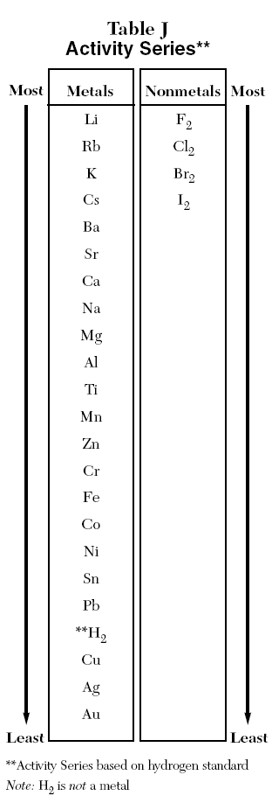**General Rule:** Elements on the _______ in Table J are___________reactive than the elements below them

**Spontaneous rxn** = rxn occurs w/out adding energy to system

* + If the “single” element is more active than the “combined” element, the single replacement reaction will be spontaneous.

**Non-spontaneous rxn** = rxn will not occur unless energy is added to system

* + If the “single” element is less active than the “combined” element, the reaction will NOT be spontaneous.

##### Complete the following equations by writing in the products formed or “no rxn”

**Ex 1:** Zn + PbCl2 🡪 **Ex 2:** Zn + BaO 🡪

**Ex 3:** Ca + CrF2 🡪

**Ex 4:** Mn + NiS 🡪

**Ex 5:** Fe + MgI2 🡪 **Ex 6:** Co + PbCl2 🡪

**PRACTICE PROBLEMS USING TABLE J**

1. According to Table J, which metal is more easily oxidized: Cr or K? Explain how you know.
2. Given the following reaction:

__Zn(s) + ___Cu(NO3)(aq) 🡪 ___Cu(s) + ___Zn(NO3)2(aq)

* 1. Write the half reactions and balance.
  2. Which chemical species was reduced?
  3. Explain why your answer to 2b was consistent with Table J.

1. Base your answer on the balanced equation below.

Fe(s) + 2HNO3(aq) → Fe(NO3)2(aq) + H2(g).

Explain, using information from Reference Table *J*, why this reaction is spontaneous.

1. The outer structure of the Statue of Liberty is made of copper metal. The framework is made of iron. Over time, a thin green layer (patina) forms on the copper surface. Where the iron framework came in contact with the copper surface, a reaction occurred in which iron was oxidized. Using information from Reference Table *J*, explain why the iron was oxidized.

**Activity Series and Oxidation Reduction**

1. Predict if each of these reactions will occur.
2. If there is a reaction predict the products
3. Assign oxidation numbers to determine which substance was oxidized and which was reduced.

1. Zn + HCl

2. Al + LiCl3

3. Mg + CuSO4

4. Cr + BaO

5. Al + FeO

6. Na + Zn(OH)2

7. Ag + AlCl3

8. Br2 + NaCl

9. Cl2 + NaBr

10. Br2 + CaI2

11. Cu + H2SO4

12. Na + H2SO3

13. Ca + HCl

14. Ag + HCl

## ELECTROCHEMICAL CELLS

#### Voltaic (similar to a battery)

1. Electrolytic (similar to alternator in cars)

**SIMILARITIES BETWEEN THE TWO:**

* Both involve REDOX reactions; CHEMICAL REACTIONS which involve the flow of ELECTRONS
* Both involve the flow of ELECTRICAL ENERGY, or CURRENT, measured in VOLTS
* Both have 2 ELECTRODES (conductive surfaces where oxidation or reduction occurs); called the ANODE and the CATHODE
* OXIDATION **or** REDUCTION occurs in each half cell

# RED CAT AN OX

Reduction ALWAYS occurs at the cathode

(ions gain e-)

[](http://images.google.com/imgres?imgurl=www.lonvig.dk/cat-red.jpg&imgrefurl=http://www.lonvig.dk/jack-english.htm&h=-1&w=-1&prev=/images%3Fq%3Dred%2Bcat%26svnum%3D20%26hl%3Den%26lr%3D%26ie%3DUTF-8%26oe%3DUTF-8%26safe%3Doff%26sa%3DG)Oxidation ALWAYS occurs at the anode

[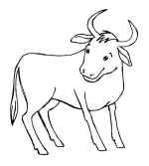](http://www.kdla.net/libserv/children/srp2002/Babe_the_blue_ox_small1.jpg)(metal loses e-)

* Electrons flow through the WIRE from the ANODE to the CATHODE.

## 

## Voltaic Cells

* A device that SPONTANEOUSLY converts CHEMICAL energy into ELECTRICAL energy or generates electric CURRENT.
* Example: Batteries

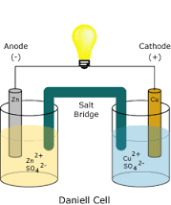

###### CATHODE

* + The LESS ACTIVE of the 2 metals (Table J)
  + SPONTANEOUSLY ATTRACTS ELECTRONS to it
  + the POSITIVE electrode in a VOLTAIC CELL
  + electrode where REDUCTION occurs (RED CAT)

###### ANODE

* + The MORE ACTIVE of the 2 metals (Table J)
  + SPONTANEOUSLY LOSES ELECTRONS to cathode
  + the NEGATIVE electrode in a VOLTAIC CELL
  + electrode where OXIDATION occurs (AN OX)

###### *SALT BRIDGE

* + provides a path for the FLOW OF IONS between the half-cells
  + prevents the BUILD-UP OF CHARGE

# Labeling Electrochemical Cell Diagrams

Directions: For each cell below:

Write

Reduction half reaction below the correct half cell

Oxidation half reaction below the correct half cell

Overall reaction

Label

Anode and cathode

Direction and region of electron flow

Direction and region of positive ion flow

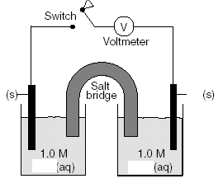

Ni+2(aq)

Co+3(aq)

Ni(s)

Co(s)



Cu+2(aq)

Zn+2(aq)

Cu(s)

Zn(s)



Pb+2(aq)

Cu+2(aq)

Pb(s))

Cu(s)



Pb+2(aq)

Al+3(aq)

Pb(s)

Al(s)

**The Voltaic Cell Example #1**



Answer the questions below referring to the above diagram.

1. Which is more easily oxidized, metal, aluminum or lead?
2. What is the balanced equation showing the spontaneous reaction that occurs?
3. What is the direction of electron flow in the wire?
4. What is the direction of positive ion flow in the salt bridge?
5. Which electrode is decreasing in size?
6. Which electrode is increasing in size?
7. What is happening to the concentration of aluminum ions?
8. What is happening to the concentration of lead ions?
9. What is the voltage in this cell when the reaction reaches equilibrium?
10. Which is the anode?
11. Which is the cathode?
12. What is the positive electrode?
13. What is the negative electrode?

**The Voltaic Cell Example #2**

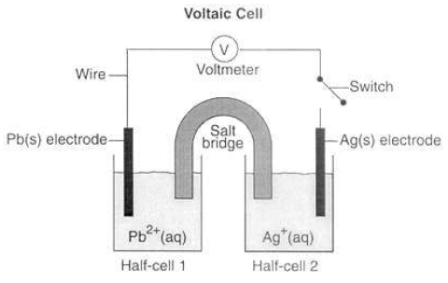

1. Use Table J to predict the direction that electrons will *spontaneously*

flow. Draw arrows to indicate the direction on the wire.

1. Based on your answer above, which would be the negative electrode and which would be the positive electrode?
2. Explain your answer to #2.
3. At which electrode or in which half-cell does oxidation occur?

Write the equation( Oxidation Half Rxn)

1. At which electrode or in which half-cell does reduction occur?

Write the equation ( Reduction Half Rxn)

1. Which electrode is the cathode?
2. Which electrode is the anode?

##### *Electrons don’t flow **to** the cathode, they flow **through** it to the ions in solution. That’s why the cathode never becomes negative.

##### Cu+2(aq) Zn+2(aq) Cu(s) Zn(s)

**Voltaic Cells, Example #3**

1. Half Reactions: _______________________ ______________________________
2. Balanced Net Reaction: _______________________________________________________
3. Identify the direction of electron flow
4. Identify the direction in which + ions will move
5. Circle the anode on the diagram.
6. Put a box around the cathode on the diagram.
7. Label each electrode whether it is + or -
8. Which electrode will increase in mass? ________________________________
9. Which ion concentration will increase? _________________________________

**Voltaic Cells, Example #4**

**

Cu+2(aq)

Ag+(aq)

Cu(s)

Ag(s)**

1. Half Reactions: _______________________ ______________________________
2. Balanced Net Reaction: _______________________________________________________
3. Identify the direction of electron flow
4. Identify the direction in which + ions will move
5. Circle the anode on the diagram.
6. Put a box around the cathode on the diagram.
7. Label each electrode whether it is + or -
8. Which electrode will increase in mass? ________________________________
9. Which ion concentration will increase? _________________________________

**Voltaic Cells, Example #5**

**

Pb+2(aq)

Au+(aq)

Pb(s)

Au(s)**

Half Reactions: _______________________ ______________________________

Balanced Net Reaction: _______________________________________________________

Identify the direction of electron flow

Identify the direction in which + ions will move

Circle the anode on the diagram.

Put a box around the cathode on the diagram.

Label each electrode whether it is + or -

Which electrode will decrease in mass? ________________________________

Which ion concentration will increase? _________________________________

**Voltaic Cells, Example #6**

**

Ni+2(aq)

Co+3(aq)

Ni(s)

Co(s)**

1. Half Reactions: _______________________ ______________________________
2. Balanced Net Reaction: _______________________________________________________
3. Identify the direction of electron flow
4. Identify the direction in which + ions will move
5. Circle the anode on the diagram.
6. Put a box around the cathode on the diagram.
7. Label each electrode whether it is + or -
8. Which electrode will decrease in mass? ________________________________
9. Which ion concentration will increase? _________________________________

## Electrolytic Cells

A device that use ELECTRICAL ENERGY to force a NONSPONTANEOUS CHEMICAL REACTION to occur. This process is utilized in ELECTROLYSIS and ELECTROPLATING

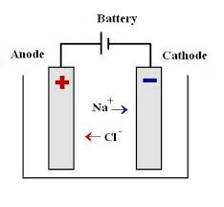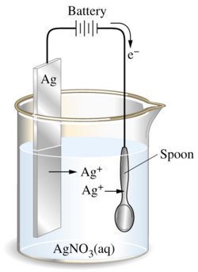

###### CATHODE

* + 1. electrode where ELECTRONS are SENT
    2. the NEGATIVE electrode (opposite of voltaic cell)
    3. electrode where REDUCTION occurs (RED CAT)

###### ANODE

* + 1. electrode where ELECTRONS are DRAWN AWAY FROM
    2. the POSITIVE electrode (opposite of voltaic cell)
    3. electrode where OXIDATION occurs (AN OX)

###### NOTICE:

* + - 1. There is NO SALT BRIDGE. This is a forced chemical reaction.
      2. You will always see a POWER SOURCE hooked up to an electrolytic cell which drives the FORCED RXN

The diagram below shows a spoon being silver plated.

a. What type of cell is this/ what is the name of this cell? _____________

b. What reaction occurs at the anode? _________________________

c. Write the Half Rx that occurs at anode. _______________________________________

1. What reaction occurs at the cathode? _______________________________________
2. Write the Half Rxn _________________________________
3. Label the anode and cathode in the diagram.

g. With an arrow, show the direction of travel of electrons between the battery and the spoon

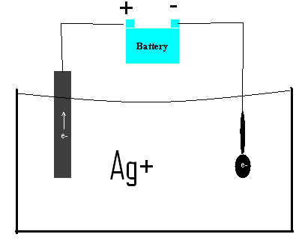

**Electrolytic Cell -Electrolysis of water**

The diagram below shows a system in which water is being decomposed into oxygen gas

and hydrogen gas. Litmus is used as an indicator in the water. The litmus turns red in test tube 1 and blue in test tube 2.



The oxidation and reduction occurring in the test tubes are represented by the balanced

equations below.

Test tube 1: 2H2O(l) 🡪 O2(g)  4H(aq)  4e1-

Test tube 2: 4H2O(l)  4e-1 🡪 2H2(g)  4OH1-(aq)

1. Determine oxidation numbers for the species (chemical substances) in each of the two test tubes.
2. Determine the change in oxidation number of oxygen during the reaction in test tube 1.
3. Which test tube contains the cathode? Explain how you know.
4. Identify the information in the diagram that indicates this system is an electrolytic cell.
5. Explain, in terms of the products formed in test tube 2, why litmus turns blue in test tube 2.

**Compare and contrast the two types of electrochemical cells:**

|  |  |  |
| --- | --- | --- |
|  | **GALVANIC/VOLTAIC** | **ELECTROLYTIC** |
| Flow of e-  (spontaneous or forced) |  |  |
| (+) electrode |  |  |
| (-) electrode |  |  |
| *Direction of e- flow |  |  |
| Reduction ½ cell |  |  |
| Oxidation ½ cell |  |  |

**\*Direction of e- flow is either “Anode → Cathode” or “Cathode → Anode”**