**Image 1**

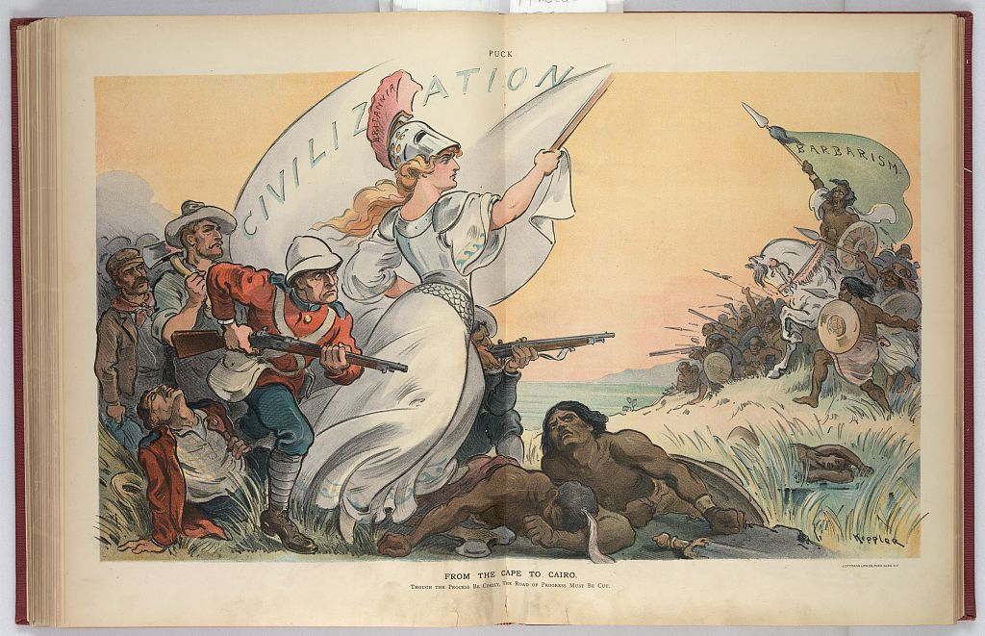

**From the Cape to Cairo / Udo Keppler (1902)**

Source: <http://www.loc.gov/pictures/item/2010652189/>

**Image 2**

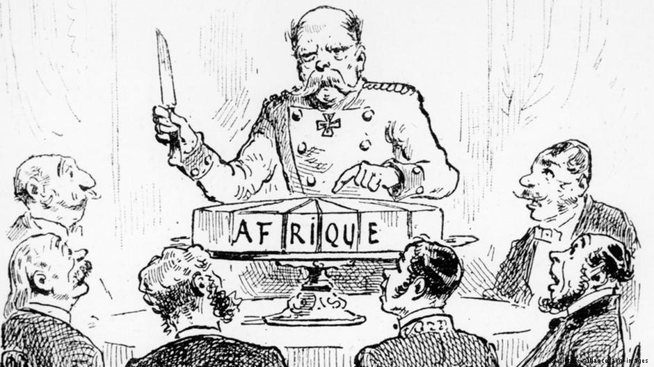

**Image 3**

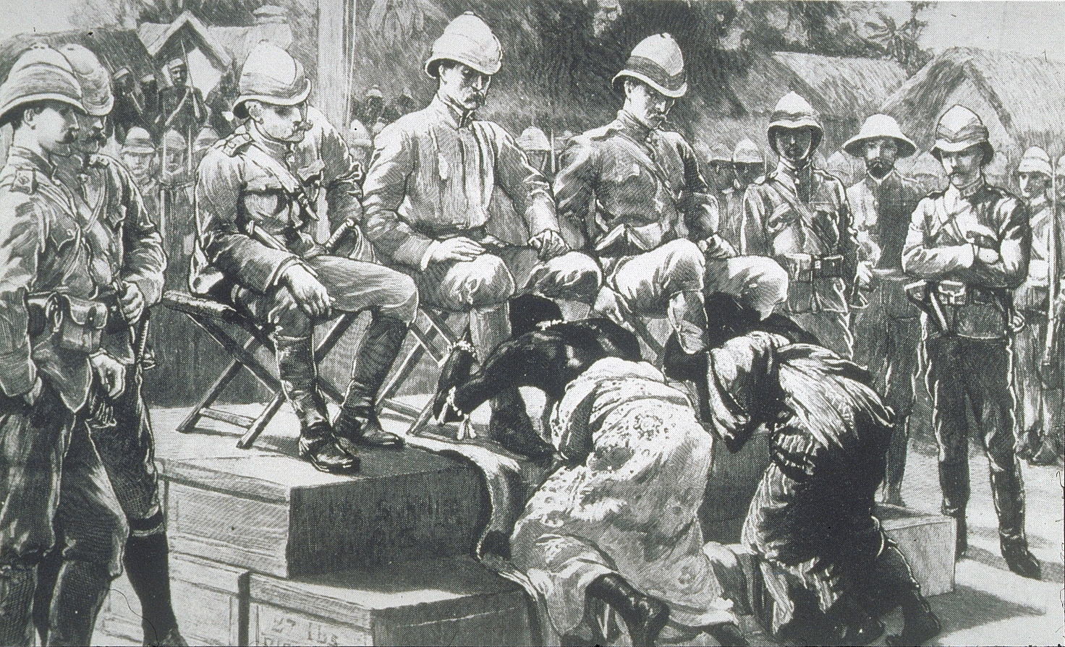

**The Submission of King Prempeh: The Final Act of Humiliation, 1896**

After taking the city of Kumasi in Ashanti, (in present-day Ghana), Governor Maxwell, from the United Kingdom compels King Prempeh and the Queen Mother to make an act of submission to him in accordance with Ashanti custom - they accordingly bend down in front of him and Sir Francis Scott and Colonel Kempster and clasp their legs.

Source: <http://historyproject.ucdavis.edu/marchandslides.bak/brantley_cynthia/images/2-IMG00205.jpg>

**Image 4**

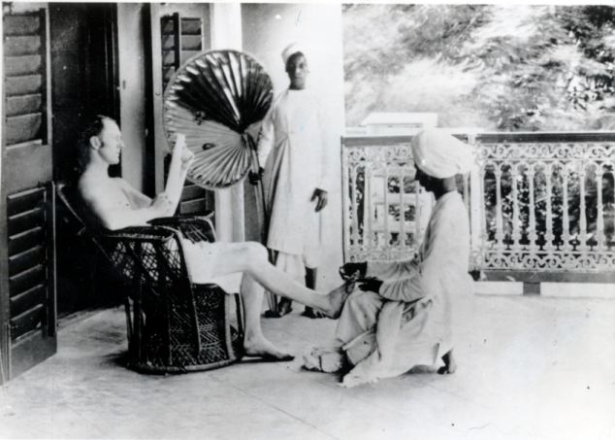

**British Raj: The life of a British Army officer during the early days of British rule in India**

Source: <http://www.dailymail.co.uk/debate/article-1298569/Britain-need-make-apology-India-Empire-.html#ixzz3tBc3zCc6>

**Image 5**

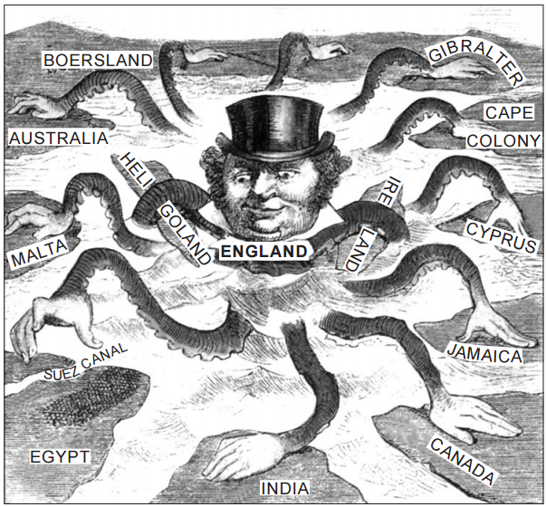

**The Devilfish in Egyptian Waters**

Source: The British Empire in the Nineteenth Century, Highsmith, 2000 (adapted) from the NYS

**Image 6**

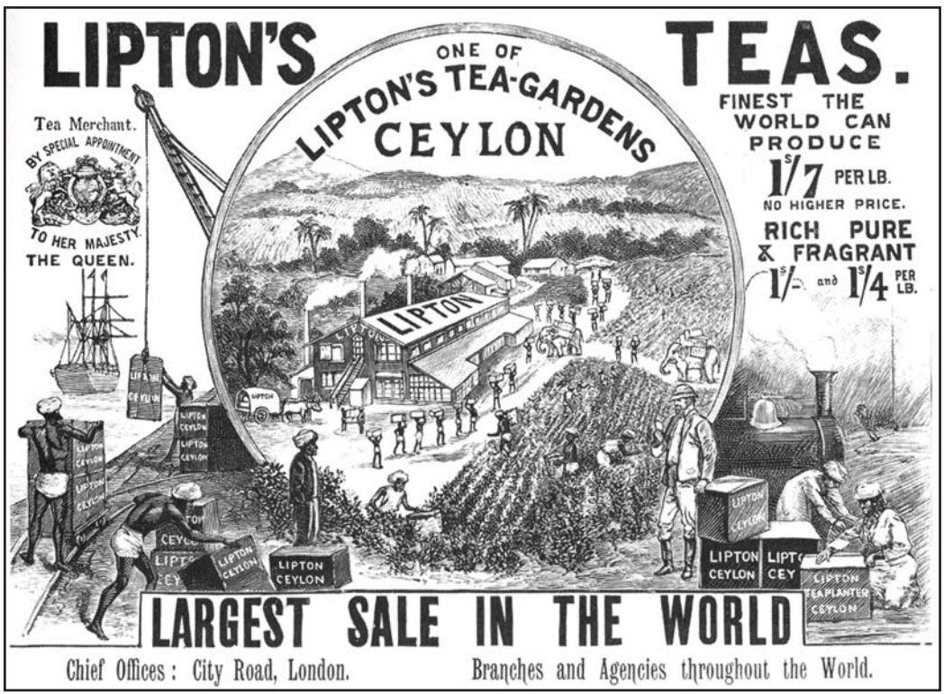

Source: Andrea and Overfield, The Human Record, Houghton Mifflin, 2001 from the NYS Global History and Geography Regents Exam, June 2004.

**Image 7**

