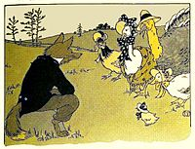

Haz un dibujo de la historia.

Draw a picture from the story.

|  |
| --- |
|  |

¿Cuál fue el astuto plan de Foxy Loxy?

What was Foxy Loxy’s cunning plan?

______________________________________________________________________________________________________________________________