Name Understanding Texts

**DIRECTIONS** : Re ad the story. Answer the questions.

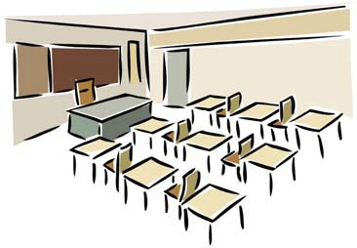.

John’s New School

John and his mother were on their way to John’s new school. John was worried. “What if nobody likes me?” he asked his mother. “Did people like you at you old school?” his mother asked. “Yes,” John said. “Then people will like you here.” Then John had another scary thought. “What if I go to the wrong classroom?” he asked his mother. “What if I sit there all day and no one else comes in? I’ll be all alone!” “You will not go to the wrong classroom,” his mother said. “I am going to take you to school and I will make sure you get to the right place.” His mother parked the car and they got out. John grabbed her hand. “Don’t let go of me!” he pleaded. His mother squeezed his hand and they went inside. They went to the principal’s office. “Welcome, John,” Principal Walters said. She was a nice lady with a friendly smile. “If you want to say goodbye to your mother, I have a classmate of yours coming to take you to your classroom.” John did not want to say goodbye to his mother. But just then another boy knocked and stepped into the office. “Charlie!” John said, dropping his mother’s hand. “Mom! It’s Charlie from summer camp!” “You are the new student?” Charlie asked, with a big grin on his face. “Great! I am here to take you to your class!” John followed Charlie out of the office and down the hall. He wasn’t worried about his new school anymore!

Name Understanding Texts

1. What is John worried about?



1. being late for school
2. going to summer camp
3. starting at a new school

2. How does John’ s mother act?

1. She helps John feel better.
2. She tells John to get over it.

B. She makes John feel worse.

1. What does John think of Principal Walters?
   1. He thinks she looks mean.
   2. He thinks she looks nice and friendly.
   3. He is afraid of her.

4. What makes John feel better?

1. His mother walks him into the school.
2. Principal Walters makes she he gets to his classroom.
3. He finds Charlie, his friend from summer camp.