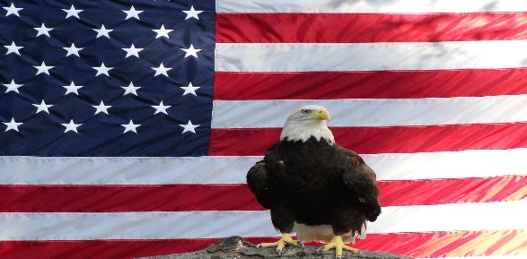

En este día de mayo, honramos a los hombres y mujeres que han dado sus vidas para que podamos tener las libertades que disfrutamos en nuestro país, los Estados Unidos de América.

Escribe sobre una libertad por la que estés agradecido.

______________________________________________________________________________

On this day in May, we honor the men and women who have given their lives so that we may have the freedoms that we enjoy in our country, the United States of America.

Write about one freedom you are thankful for.

**Mrs. O’Meara**

**I am thankful that I was free to go to school to become a teacher.**

**_____________________________________________________________________________________________________________________________________________________________________**