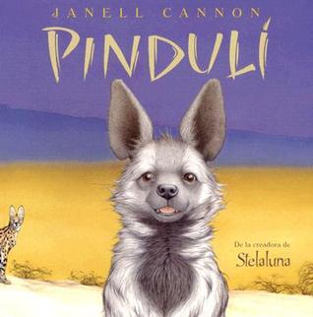

Haz un dibujo de la historia. Etiqueta tu foto.

Draw a picture from the story. Label your picture.

|  |
| --- |
|  |

¿Qué tipo de animal es Pinduli?

What kind of animal is Pinduli?

______________________________________________________________________________________________________________________________