**Name: Using Details to Determine the Main Idea**

**What is the Main Idea?**

Have you ever wondered why trees have so many different colors during the fall months? Most trees grow their leaf buds in the color green during the spring and the summer months. However, during the fall months, some of the trees that were once green are now yellow, orange, red, brown, or a mixture of colors.

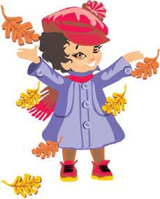

During the spring and summer seasons, tree leaves are busy making food for the tree. They use water from rain, light from the sun, and carbon dioxide to make food. When the leaves are healthy making food, their color is usually some shade of green. The green color comes from the inside of the leave’s cells.

When the weather starts to turn cool for the fall, the tree stops the leaves from making food so that it can go dormant in the wintertime. During the winter, the air is very cold and there will not be as much sun light to help the leaves keep making food for the tree. As the leaves stop making food, their cells begin to die. As the leave’s cells are dying, the other colors that were in the leaf the whole time begin to show. If the leaf is turning red, the red color was in the leaf the whole time. Red could not be seen when the leaf was making food for tree. If the leaf turns brown, yellow, or orange, those colors were hiding in the leaf during the spring and summer months.

Without food, the leaf will eventually die and fall away from the tree it once fed. During the winter months, the tree will not grow any new leaves. New leaves will start budding as the air gets warmer and the sun is out longer during the spring. By summer time, new leaves will be making food once again for the tree.

# Use the paragraphs above to determine the important details and main idea.

**List 2 important details List 2 important details List 2 important details**

CCSS.RI.2.2 | © [www.EnglishWorksheetsLand.com](http://www.EnglishWorksheetsLand.com/)