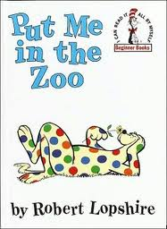

¿Qué harías si tuvieras puntos mágicos?

Dibuja una imagen

What would you do if you had magic spots?

Draw a picture

|  |
| --- |
|  |

Escribe una oración sobre tu dibujo.

Write a sentence about your picture.

______________________________________________________________________________________________________________________________