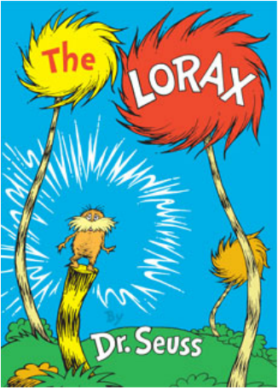

Haz un dibujo de la historia. Etiqueta tu foto.

Draw a picture from the story. Label your picture.

|  |
| --- |
|  |

¿Por qué el Lorax estaba triste?

Tell why the Lorax was sad?

______________________________________________________________________________________________________________________________