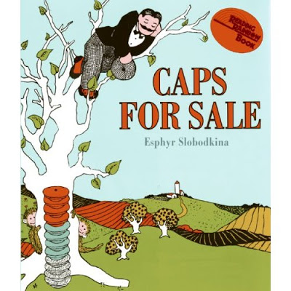

Draw a picture of the monkeys throwing their caps on the ground.

|  |
| --- |
|  |

Tell why you think the monkeys threw the caps on the ground.