**Mamo Is Trading Again!**

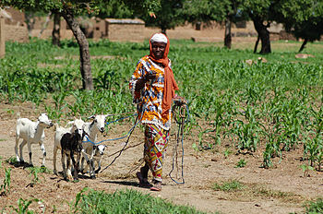

1. Who are the characters in the story? (page 2)

The characters in the story are **_______________,** ______________, ____________, __________________, and ________________.

2. The story takes place in **____________________________.**

3. Mamo’s father gives him the game board so he will **_________________________________________.**? (page 5)

4. What did the man do with Mamo’s game board? (page 7)

5. Why does Mamo smile at the end of the story when his father asks him if the board kept him out of trouble? (page 32)