PROTEST…Speak up when you disagree with something!

You can protest too. You can make a sign that says how you feel! 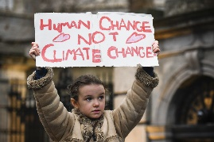

Examples of protest signs: Look at each picture. What do you see? Can you guess what they mean?

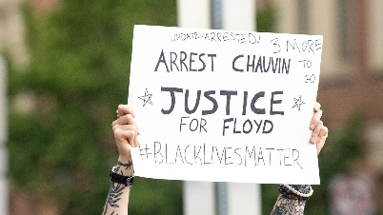 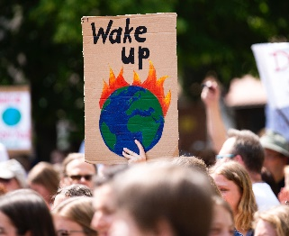 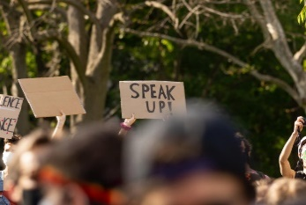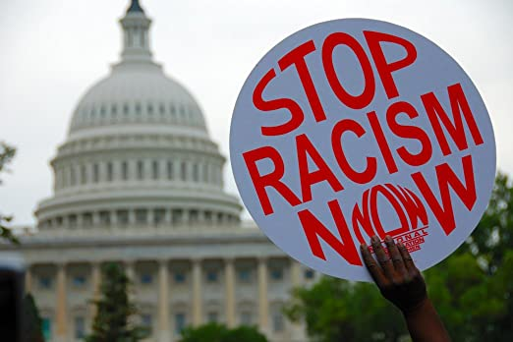 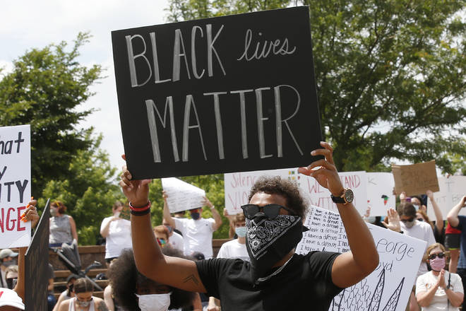 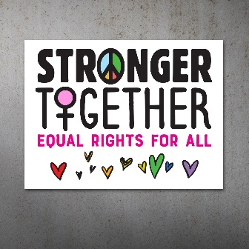

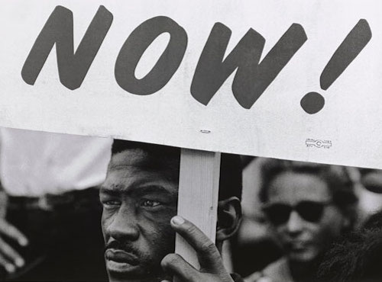

Create your own Protest Sign:

1. Get the needed materials to create a protest sign: cardboard, poster board, construction paper etc., markers, paints, crayons, sticks (popsicle sticks, rulers—anything to hold up your sign) and tape.
2. Now about anything in your world that really bothers you. Think about something you know about that feels unfair or anything in the world that hurts people that you would protest if you could.

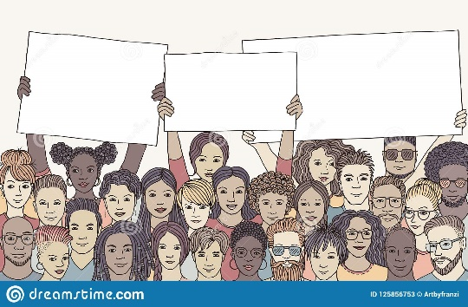

1. Think of a phrase or few short sentences that tell about your idea. (For example, **Black Lives Matter)** Choose one that will go on your sign. You can draw pictures or symbols if you like. Finally, create your own protest sign and email a picture of it to me.