Name: Nonfiction: Text Features – Q1:6 Date:
As you answer this week’s questions, highlight your evidence in the text.
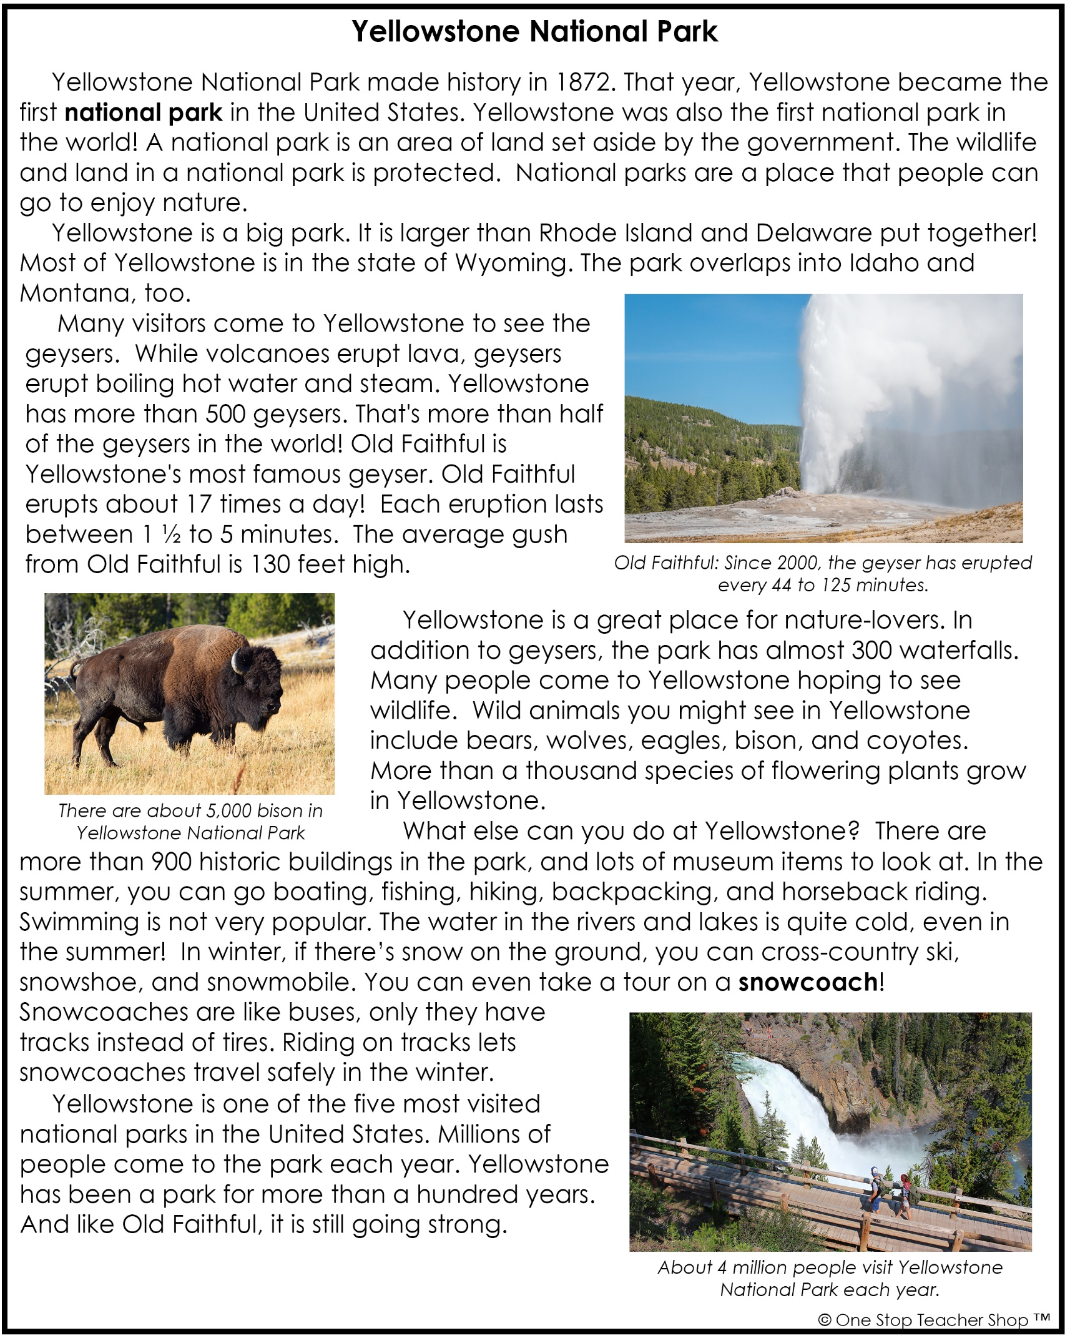

Nonfiction: Text Features – Q1:6
Monday | Tuesday
Before you read, make a prediction about the text based on the title and text features.  ___________________________________________ | Where is a majority of Yellowstone located?  ___________________________________________
What text features are included in this article?  ___________________________________________ | Based on the article, how is a geyser different from a volcano?  ___________________________________________
Based on the text, what is a national park?  ___________________________________________ | How long might you have to wait to see Old Faithful erupt?  ___________________________________________
Complete the sentence.  National parks are a place that people can go to enjoy ___________________. | Where did you find the answer to the question above?  ___________________________________________
Wednesday | Thursday
Why kind of information do the captions in this article give you?  ___________________________________________ | How are snowcoaches different than buses?  ___________________________________________
Why do you think the author included a picture of a bison in this article?  ___________________________________________ | Why do you think the author decided to include photographs in the article?  ___________________________________________
What summer activity is not popular at Yellowstone? Why?  ___________________________________________ | What fact about Yellowstone did you learn from the last caption?  ___________________________________________
Based on the text, what is a snowcoach?  ___________________________________________ | Based on the article, what is one reason you might want to visit Yellowstone?  ___________________________________________
More of My Thinking
Monday | Tuesday
__________________________________________________________________________________________________________________________________________________________________________________________________________________________________________________________________ | __________________________________________________________________________________________________________________________________________________________________________________________________________________________________________________________________
Wednesday | Thursday
__________________________________________________________________________________________________________________________________________________________________________________________________________________________________________________________________ | __________________________________________________________________________________________________________________________________________________________________________________________________________________________________________________________________

My Progress
MONDAY  _____ out of 4 correct  I need more help with…  _____________________  _____________________  _____________________ | TUESDAY  _____ out of 4 correct  I need more help with…  _____________________  _____________________  _____________________ | WEDNESDAY  _____ out of 4 correct  I need more help with…  _____________________  _____________________  _____________________ | THURSDAY  _____ out of 4 correct  I need more help with…  _____________________  _____________________  _____________________

