Name: Nonfiction: Context Clues – Q1:4 Date:

*As you answer this week’s questions, highlight your evidence in the text.*

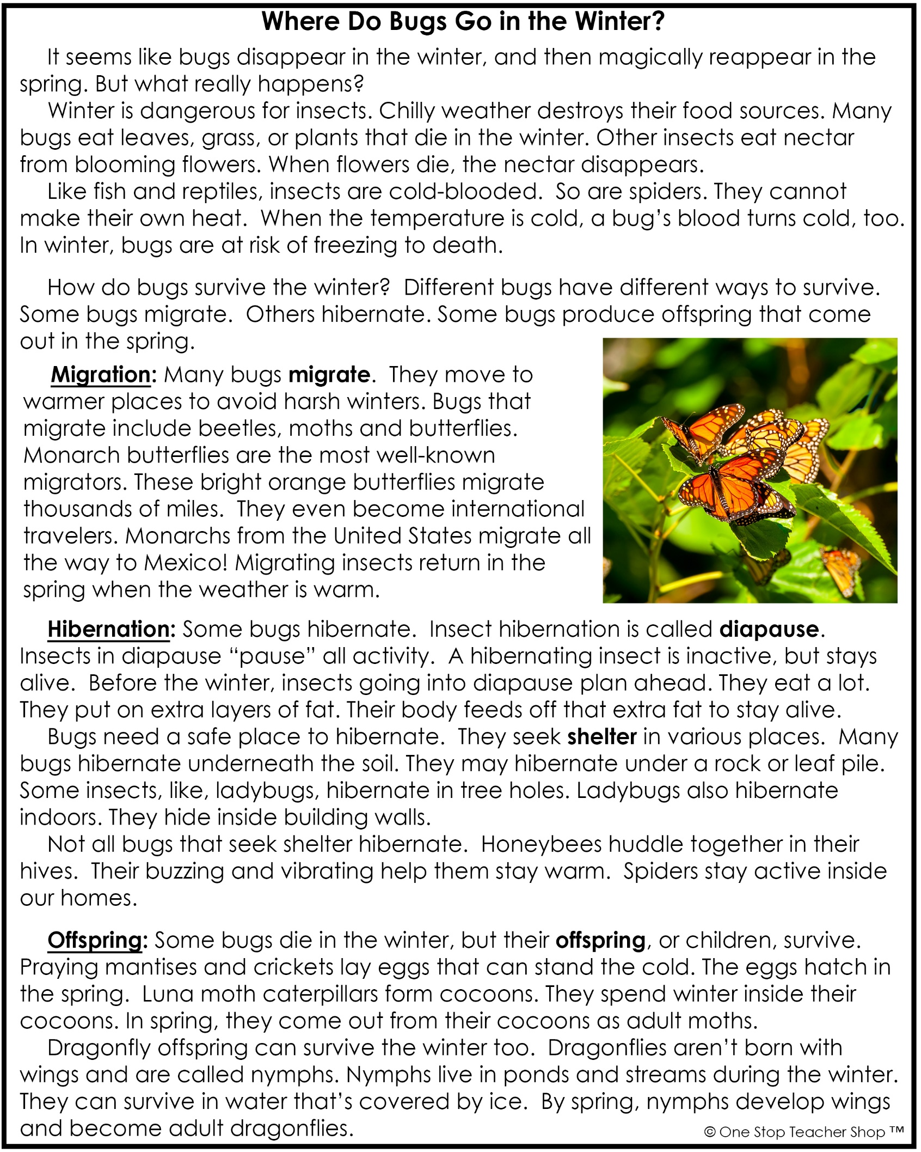

Nonfiction: Context Clues – Q1:4

|  |  |
| --- | --- |
| **Monday** | **Tuesday** |
| **Before** you read, make a prediction about the text based on the title, pictures, and bold words.  ___________________________________________ | What might happen to a cold-blooded insect during winter?  ___________________________________________ |
| What season is dangerous for insects?  ___________________________________________ | What insect migrates all the way to Mexico just to avoid cold winters?  ___________________________________________ |
| Why can’t a bug eat nectar during winter?  ___________________________________________ | During what season do migrating insects return home?  ___________________________________________ |
| Based on the text, what is the meaning of the word **migrate**?  ___________________________________________ | Based on the text, what is the meaning of the word **diapause**?  ___________________________________________ |
| **Wednesday** | **Thursday** |
| What must a hibernating insect do before winter?  ___________________________________________ | Based on the text, what insects lay eggs that can survive the winter?  ___________________________________________ |
| How does extra fat help a hibernating insect?  ___________________________________________ | How do luna moth caterpillars survive the winter?  ___________________________________________ |
| What insect sometimes hibernates indoors?  ___________________________________________ | How is a nymph different from an adult dragonfly?  ___________________________________________ |
| Based on the text, what is the meaning of the word **shelter**?  ___________________________________________ | Based on the text, what is the meaning of the word **offspring**?  ___________________________________________ |

More of My Thinking

|  |  |
| --- | --- |
| Monday | Tuesday |
| __________________________________________________________________________________________________________________________________________________________________________________________________________________________________________________________________ | __________________________________________________________________________________________________________________________________________________________________________________________________________________________________________________________________ |
| Wednesday | Thursday |
| __________________________________________________________________________________________________________________________________________________________________________________________________________________________________________________________________ | __________________________________________________________________________________________________________________________________________________________________________________________________________________________________________________________________ |

My Progress

|  |  |  |  |
| --- | --- | --- | --- |
| MONDAY  _____ out of 4 correct  I need more help with…  _____________________  _____________________ _____________________ | TUESDAY  _____ out of 4 correct  I need more help with…  _____________________  _____________________ _____________________ | WEDNESDAY  _____ out of 4 correct  I need more help with…  _____________________  _____________________ _____________________ | THURSDAY  _____ out of 4 correct  I need more help with…  _____________________  _____________________ _____________________ |