Name: Nonfiction: Text Features – Q1:5 Date:
As you answer this week’s questions, highlight your evidence in the text.
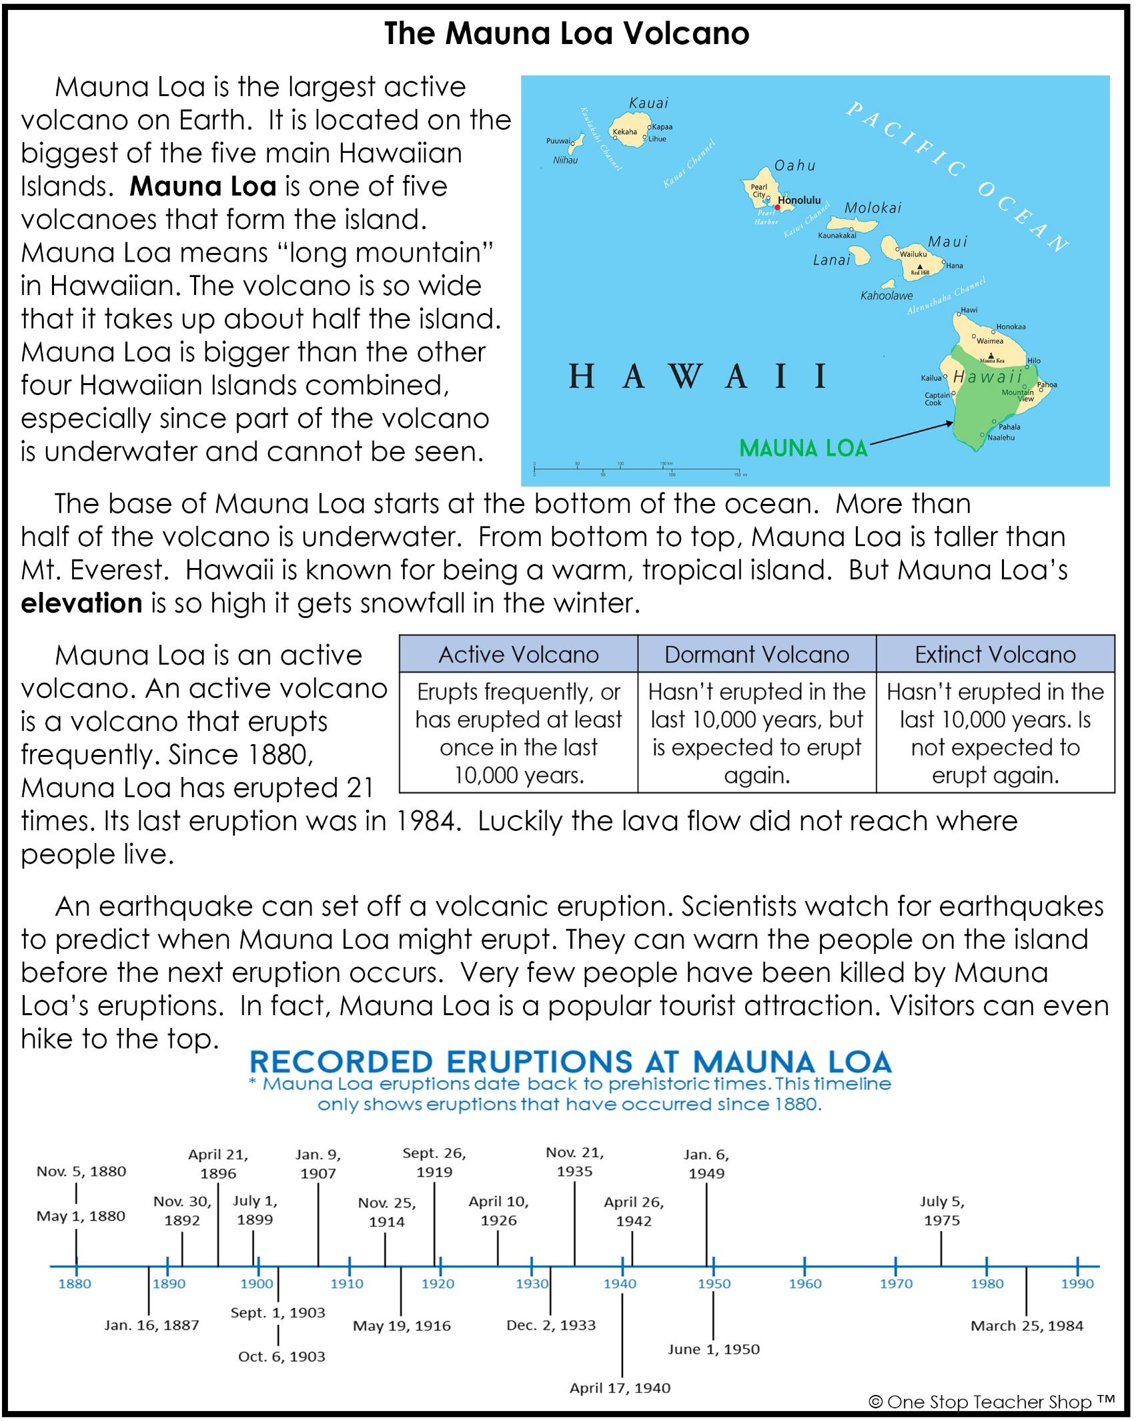

Nonfiction: Text Features – Q1:5
Monday | Tuesday
Before you read, make a prediction about the text based on the title and text features.  ___________________________________________ | Based on the text, what is the meaning of the phrase Mauna Loa?  ___________________________________________
What text features are included in this article?  ___________________________________________ | Write one detail from the text that supports Mauna Loa is a very big volcano.  ___________________________________________
Where is Mauna Loa located?  ___________________________________________ | Why are you unable to see half of Mauna Loa?  ___________________________________________
Which text feature helps you find the location of Mauna Loa?  ___________________________________________ | Which mountain does the author compare Mauna Loa to?  ___________________________________________
Wednesday | Thursday
Based on the text, what is the meaning of the word elevation?  ___________________________________________ | What information do you gain from the timeline?  ___________________________________________
Why does it snow at the top of Mauna Loa in the winter?  ___________________________________________ | Why do scientists watch for earthquakes?  ___________________________________________
What is an active volcano?  ___________________________________________ | True or False?  Mauna Loa first erupted in 1880.  ___________________________________________
Based on the table, how is an active volcano different from a dormant volcano?  ___________________________________________ | Based on the timeline, when did Mauna Loa last erupt?  ___________________________________________
More of My Thinking
Monday | Tuesday
__________________________________________________________________________________________________________________________________________________________________________________________________________________________________________________________________ | __________________________________________________________________________________________________________________________________________________________________________________________________________________________________________________________________
Wednesday | Thursday
__________________________________________________________________________________________________________________________________________________________________________________________________________________________________________________________________ | __________________________________________________________________________________________________________________________________________________________________________________________________________________________________________________________________

My Progress
MONDAY  _____ out of 4 correct  I need more help with…  _____________________  _____________________  _____________________ | TUESDAY  _____ out of 4 correct  I need more help with…  _____________________  _____________________  _____________________ | WEDNESDAY  _____ out of 4 correct  I need more help with…  _____________________  _____________________  _____________________ | THURSDAY  _____ out of 4 correct  I need more help with…  _____________________  _____________________  _____________________

