Name: Nonfiction: Explicit Meaning – Q1:2 Date:

*As you answer this week’s questions, highlight your evidence in the text.*

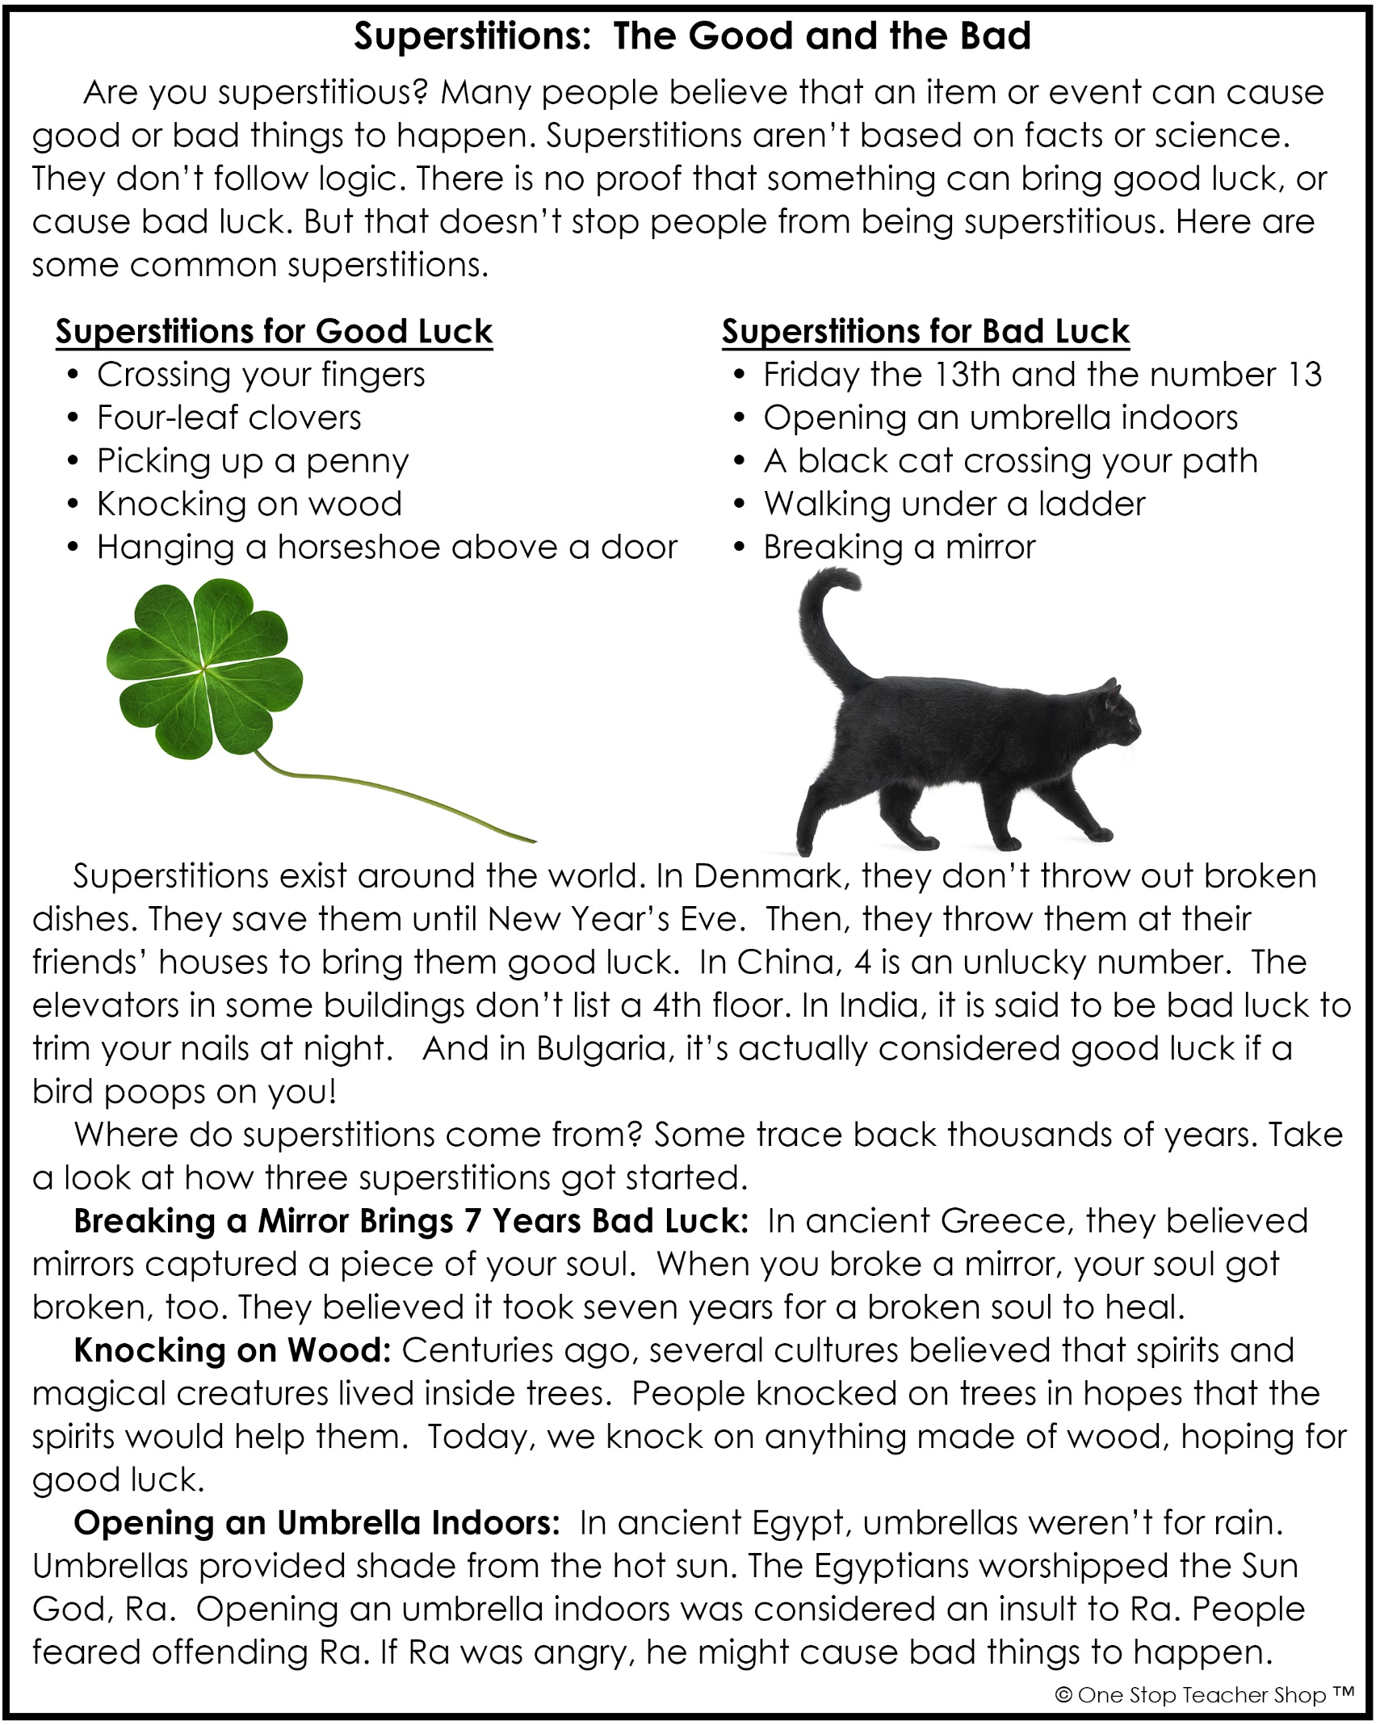

Nonfiction: Explicit Meaning – Q1:2

|  |  |
| --- | --- |
| **Monday** | **Tuesday** |
| **Before** you read, make a prediction about this text based on the title.  ___________________________________________ | Fill in the missing word.  Some people believe walking under a ladder will bring you _______________ luck. |
| Using a timer, see how long it takes you to read the entire text. Record your time below. Ask someone for help.  _______ minutes _______ seconds | According to the article, what is one superstition people believe will bring you bad luck?  ___________________________________________ |
| If someone is superstitious, they believe…  ___________________________________________ | Where do superstitions exist?  ___________________________________________ |
| Fill in the missing word.  Some people believe crossing your fingers will bring you _______________ luck. | Based on the text, what do people in Denmark do with broken dishes?  ___________________________________________ |
| **Wednesday** | **Thursday** |
| What number is unlucky in China?  ___________________________________________ | Using a timer, see how long it takes you to read the entire story. Record your time below. Did your time improve?  _______ minutes _______ seconds |
| What is one superstition people believe will bring you good luck?  ___________________________________________ | What kind of luck do people hope to get when they knock on wood?  ___________________________________________ |
| What do people in India believe will bring you bad luck?  ___________________________________________ | Who believed it was bad luck to open an umbrella indoors?  ___________________________________________ |
| Based on the text, how many years of bad luck will you have if you break a mirror?  ___________________________________________ | Are you superstitious?  ___________________________________________ |

More of My Thinking

|  |  |
| --- | --- |
| Monday | Tuesday |
| __________________________________________________________________________________________________________________________________________________________________________________________________________________________________________________________________ | __________________________________________________________________________________________________________________________________________________________________________________________________________________________________________________________________ |
| Wednesday | Thursday |
| __________________________________________________________________________________________________________________________________________________________________________________________________________________________________________________________________ | __________________________________________________________________________________________________________________________________________________________________________________________________________________________________________________________________ |

My Progress

|  |  |  |  |
| --- | --- | --- | --- |
| MONDAY  _____ out of 4 correct  I need more help with…  _____________________  _____________________ _____________________ | TUESDAY  _____ out of 4 correct  I need more help with…  _____________________  _____________________ _____________________ | WEDNESDAY  _____ out of 4 correct  I need more help with…  _____________________  _____________________ _____________________ | THURSDAY  _____ out of 4 correct  I need more help with…  _____________________  _____________________ _____________________ |