Name: Fiction: Fluency – Q1:1 Date:

*As you answer this week’s questions, highlight your evidence in the text.*

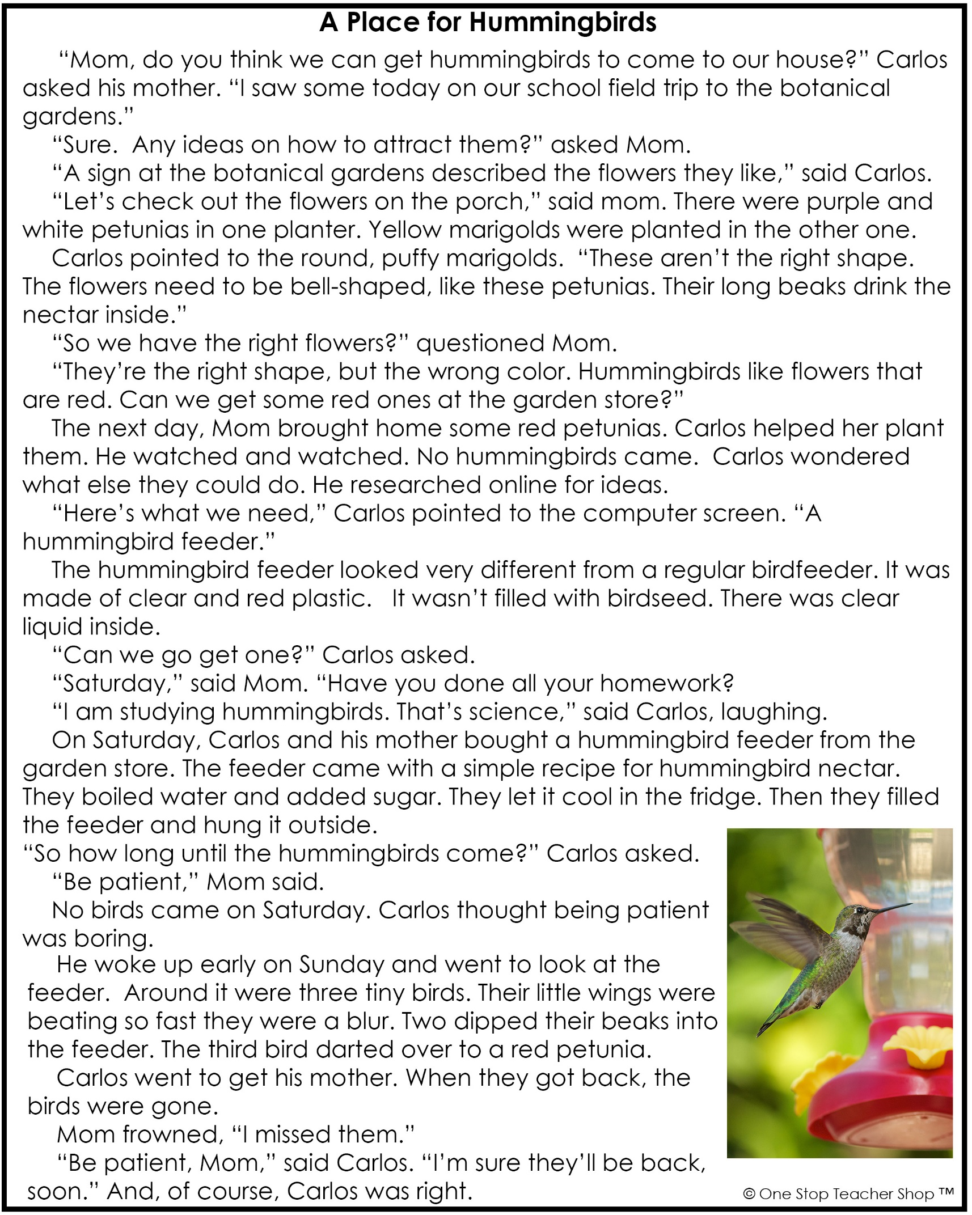

Fiction: Fluency – Q1:1

|  |  |
| --- | --- |
| **Monday** | **Tuesday** |
| **Before** you read, make a prediction about this story based on the title.  ___________________________________________ | Reread the story aloud to someone. Have the person you read to sign their name below.  Listener _______________________________ |
| Using a timer, see how long it takes you to read the entire story. Record your time below. Ask someone for help.  _______ minutes _______ seconds | How does Carlos know which flowers hummingbirds like?  ___________________________________________ |
| Who are the characters in the story?  ___________________________________________ | Based on the story, what shape flowers do hummingbirds like best?  ___________________________________________ |
| Where did Carlos go on his field trip?  ___________________________________________ | Why won’t the flowers on the porch attract hummingbirds?  ___________________________________________ |
| **Wednesday** | **Thursday** |
| Reread the story aloud to someone. Have the person you read to sign their name below.  Listener _______________________________ | Using a timer, see how long it takes you to read the entire story. Record your time below. Did your time improve?  _______ minutes _______ seconds |
| Did hummingbirds come after Carlos bought red petunias?  ___________________________________________ | What did Carlos add to the water to make the hummingbird nectar?  ___________________________________________ |
| What idea for attracting hummingbirds did Carlos find on the internet?  ___________________________________________ | On what day did Carlos finally see hummingbirds?  ___________________________________________ |
| What is one way hummingbird feeders are different from regular bird feeders?  ___________________________________________ | After reading the story, do you think it is important to be patient when bird watching?  ___________________________________________ |

More of My Thinking

|  |  |
| --- | --- |
| Monday | Tuesday |
| __________________________________________________________________________________________________________________________________________________________________________________________________________________________________________________________________ | __________________________________________________________________________________________________________________________________________________________________________________________________________________________________________________________________ |
| Wednesday | Thursday |
| __________________________________________________________________________________________________________________________________________________________________________________________________________________________________________________________________ | __________________________________________________________________________________________________________________________________________________________________________________________________________________________________________________________________ |

My Progress

|  |  |  |  |  |
| --- | --- | --- | --- | --- |
| MONDAY  _____ out of 4 correct  I need more help with…  _____________________  _____________________ _____________________ | TUESDAY  _____ out of 4 correct  I need more help with…  _____________________  _____________________ _____________________ | | WEDNESDAY  _____ out of 4 correct  I need more help with…  _____________________  _____________________ _____________________ | THURSDAY  _____ out of 4 correct  I need more help with…  _____________________  _____________________ _____________________ |
|  | | |  | | |
|  | | |  | | |
|  | | |  | | |
|  | | |  | | |
|  | | |  | | |
|  | | |  | | |
|  | | |  | | |
|  | | |  | | |
|  | | |  | | |